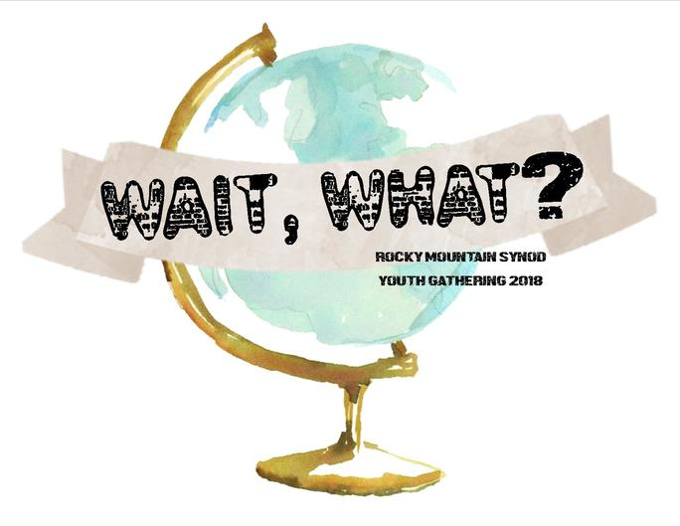
□ON THE BACK I have additional information regarding medical history, allergies, drug reactions, current prescriptions & medications being taken etc., that may be needed or useful in emergency treatment…
Rocky Mountain Synod
Youth Gathering

January 13-15, 2018
Doubletree Hotel, Colorado Springs, CO
Health & Permission Form
This form needs to be completely filled out for each participant and signed by a parent or adult participant
□ Youth □Adult Leader (2l+yo)

Participant's Name last first middle initial
Adult Email □ Male □ Female Age/Grade

Address City/State Zip

Phone □Cell □Home □Work □Other

Congregation City/State Zip
Allergies/Dietary Needs T-Shirt Size (adult sizes)

INSURANCE INFO

Insurance Company Phone

Insurance Company Address
ID# Group# Policy Holder’s Employer
EMERGENCY CONTACT (Use the reverse side to list more than one contact)

Name Relation Address City/State Zip
Phone Numbers Cell Home Work

I give permission for my child (youth participant) or I agree (adult) to travel to/from and to fully participate in this year 's Rocky Mountain Synod Youth Gathering. The undersigned agrees to hold The Rocky Mountain Synod of the ELCA, contracted Gathering support, and attending congregation named above, harmless from any claim for injury to the above named arising out of or in any way connected to the above named activity. It is also understood that possession and/or use of illegal drugs, alcohol, or weapons will result in this youth or adult being sent home at my expense. The participant above agrees to the Rocky Mountain Synod Youth Gathering Covenant. In case of emergency, I understand that every effort will be made to contact the emergency contact(s) listed. If these contacts cannot be reached, I hereby give the representatives of The Rocky Mountain Synod Youth Gathering and appointed adult volunteers of the Gathering permission to act on my behalf in seeking emergency treatment for my child/me in the event that such treatment is deemed necessary. I give permission to those administering emergency treatment to do so, using those measures deemed necessary. I understand that The Rocky Mountain Synod, the staff or volunteers from the Youth Gathering Planning Team are not responsible for any or all related injuries that may occur during these events.

Parent or Adult Participant Signature Date
Parent Printed Name:
Important Notes
Group leaders: Please bring 2 copies of this form. One copy the group leader will keep with him/her at all times. Place the 2nd copy in a folder marked with the name of your congregation! Each attending congregation must be able to fully transport their participants to the service project and in the event of an emergency (not requiring ambulatory services) during the weekend.
Photo Release:
The Rocky Mountain Synod Youth Gathering will have pictures or video taken at events that may be used for promotional material. If any participant does not want to be included in those photos, a written letter must be mailed to the Rocky Mountain Synod, two weeks prior to the event with parent’s signature.
Date forms are due Registration Cost $

