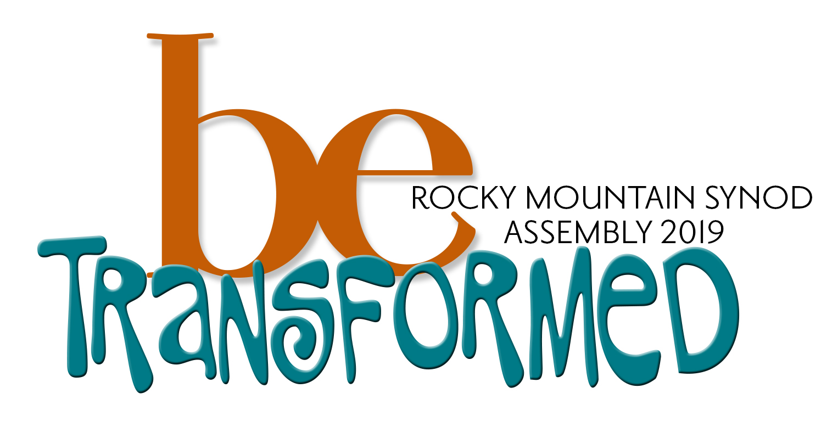

2019 Assembly Excursions and Immersions
Excursions will take place off-site; Immersions are located at the Embassy Suites. We are hoping we can arrange transportation through carpooling with other assembly attendees; shuttles will be arranged if needed. If you are requesting child care, please select an on-site immersion; children are welcome to attend an off-site excursion with you. Excursions/Immersions will be 2-3 hours long. If your event ends early, there will be open space conversations and the interactive display area available.

Off-site Excursions
Be Transformed: A Nature Excursion
Coordinator: Pastor Adam Berndt
Length: 1-3 hours, depending on choice of hike
God is good! Take a hike! Spend some time being transformed by God in a time of renewal in the beauty of God’s creation. Explore a bit of the desert wilderness while hiking around the Sandia mountains. Take a breath. Enjoy some sun. Talk along the way.

Congregational Transformation through Death and Resurrection
Host: Pastor Rachael Powell and members of St. Timothy’s
Length: 2 hours
The Holy Spirit has taken St. Tim’s through a time of intense transformation in recent years. With this experience comes incredible joy as well as great grief and uncertainty. This workshop will focus on a number of the basic themes of St. Tim’s transformation through conversation as well as hands-on experiences. The goal is for participants to encounter the Spirit’s work in and through one church’s experience of congregational transformation, but even more in and through our time together. Finally, participants will depart with tools to use in their own lives and congregational settings through which the Spirit may inspire and transform.

Indian Pueblo Cultural Center
Length: 2 hours
Cost: $6
The Indian Pueblo Cultural Center team of knowledgeable docents and Education Specialists will walk our group through their recently renovated galleries at a relaxed pace. They will offer in-depth insights on the displays of Pueblo history and culture, and answer any questions you all may have along the way. As the group is arriving on a Saturday afternoon, you all will be treated to viewing a cultural dance performed outside in their beautiful courtyard, where several murals done by Pueblo artists are also on display.

Ministry of Holding Space: Accompanying Young Adults
Host: Pastor Bre Roberts and UNM Campus Ministry students
Length: 1-1.5 hours
Limited to 30 participants
Many of our church settings are missing the “young adult” demographic, typically defined as folks from ages 18–30, and there are many programs, ministries, and ideas that congregations and communities offer in the hope of attracting young adults. But many of these ideas may fall short and never reach those whom they are designed to invite. Come visit Luther House, the place where Lutheran Campus Ministry happens at the University of New Mexico, to learn about doing ministry with and for young adults from a different perspective. Rather than creating programs for young adults, what could happen when we hold space for what young adults are already doing and go with them? Join students talking about the ways Luther House supports them, and likewise, Pastor Bre Roberts sharing the possibilities of saying “Yes!” to accompanying the visions and dreams of young adults.

National Hispanic Cultural Center
Length: 1-3 hours
Cost: $6
The Visual Art Museum: Qué Chola. The Chola is a significant figure in the Latina imagination for the ways that she represents a feminine strength, power, and resilience in the face of racial, gender, and economic adversity. She is a figure that many young Latinas in the U.S. admire and emulate. The last few years have seen a surge in interest in the Chola as a figure and this exhibition will explore this dynamic from a feminist perspective through art and popular culture.
Torreón: Mundos de Mestizaje by Frederico Vigil is a mural housed in the Torreón on the campus of the National Hispanic Cultural Center. This monumental fresco depicts thousands of years of Hispanic history highlighting diverse cultural connections between people and places from the Iberian Peninsula to the Americas. The 4,000 square foot painting is one of the largest frescos in North America.

Multicultural Fiesta at Camino de Vida Lutheran/Presbyterian Ministry
Length: 1-3 hours
Multicultural Fiesta will highlight cultural diversity, including music that features Camino de Vida's Worship Group and local musicians, heritage dancing from varying Latino and Native American cultures, food, games, sports and fun.

Red Planet Books: Indigenous People In Media and Pop Culture
Facilitator: Dr. Lee Francis IV
Length: 1 hour for presentation + 1 hour for questions and shop exploring
Limited to 15 people
For more than four hundred years, Native and Indigenous people have played a significant role in global popular culture. From the earliest portrayals of the “Noble Savage” through the villainous “Red Devil”, the images and representations of Native American and North American Indigenous Peoples have been used to shape policy and perpetuate efforts of genocide and ethnocide throughout North America. The rise of the Indigenerd coincides with concerted efforts by marginalized communities to assert themselves in establishing authentic representations within global pop culture. The inclusion/exclusion of images and representations in popular culture have a profound impact on identity development, policy creation, and direct experiences by Native and Indigenous peoples. As such, it is beneficial for Indigenous activists to take on the mantle of Indigenerd in order to challenge the misrepresentations that continue to reinforce stereotypes. This talk will explore the history of Native and Indigenous people in popular culture and highlight some of the amazing efforts of Indigenerds worldwide to actively change the representations of Native people through dynamic and powerful expressions of self and culture.

Growing Refugee Futures: A Trip to Tres Hermanas Farm
Host: Lutheran Immigration & Refugee Service (LIRS) and ELCA AMMPARO
Length: 3 hours
Taste and see what happens when former refugees are given space to grow produce for themselves and their families at Tres Hermanas, a program sponsored by Lutheran Family Services Rocky Mountains (LFSRM). Hear stories of migrants, and learn about the migrant and refugee ministries of LFSRM, AMMPARO, and LIRS.

On-site Immersions
Transforming Suffering and the Practice of Self-Compassion
Host: Rev. DanaLee Simon
Length: 3 hours
Limited to 12 participants
As Beloveds of God, we are created in Love to love – to love God, and our neighbors as we love ourselves. For many of us, this last piece is often the most difficult. We all could use more Self-Compassion which involves giving the same grace to yourself that you offer to another, especially when you are having a difficult time, fail, or notice something you don’t like about yourself. In this immersion, we will learn about and explore the three doorways into self-compassion (Mindfulness, Kindness, and Common Humanity) as taught by Dr. Kristin Neff, a lead researcher in this topic. Grounded in our Christian faith, and using prayer/meditation, art, music, poetry, self-reflection, and discussion questions, we’ll explore the transformative power of loving ourselves which has been God’s desire for us from the beginning and all along.
The Stories We Live
Host: ACT 4 RMS Racial Justice Team
Length: 3 hours
Be educated, touched and moved by stories of how people in our synod struggle to love by doing the work to dismantle racism and overcome white supremacy in the U.S.

Transformational Worship
Facilitator: Deaconess Sarah Bjornebo
Length: 2 hours
A life of faith and the drama of the Biblical texts are often experiences beyond words. Yet the practice of worship is primarily a verbal construct. What would it mean to worship God beyond words? The Arts in all forms - music, theatre, film, dance, photography, poetry,painting . . are a layering of intricate transparencies which provide a medium for communal experience. This Immersion is designed as an exploration of the creative process and the methodology of the arts in worship. How can we express the experiences of this conference beyond words?

Dismantling the Doctrine of Discovery
Facilitators: Rev. Alison George and Rev. Bonita Knox
Length: 2 hours
As the Rocky Mountain Synod, we have a continued commitment to dismantling the Doctrine of Discovery. Join us in an exercise designed to engage your whole body in learning about our early American history, especially as it pertains to our American Indian siblings. You will gain curiosity about your own homeland’s history and leave with tools and resources for continued learning and conversation in your community.

Excellence in Leadership
Facilitator: Rev. Sarah Moening
Length: 2.5 hours
Limited to 25 participants
Effective Leadership begins with self-awareness; understanding both that we are beloved children of God and being aware of our own brokenness. We are most effective as leaders in our ministries and faith communities when we allow God's creative power to transform us into agents of positive change for the sake of the world.

Excellence in Leadership brings together broad disciplines: Bible study and spiritual practices, family systems, leading from the future, adaptive leadership, and vulnerability and resiliency, all under the umbrella of emotional intelligence, with the intent of forming creative, resilient and faithful leaders who are better equipped to build courageous, resilient, and faithful communities of faith, for the sake of the world.

