Youth Gathering | Synod Assembly | Theological Conference
January 19-21, 2019  YMCA of the Rockies  Estes Park, CO | May 3-5 2019  Friday-Sunday  Embassy Suites  Albuquerque, NM  Registration: $300  Hotel: $119-129 | October 7-10, 2019  YMCA of the Rockies  Estes Park, CO  Single: $520  Double: $370  Triple: $320
January 2020 (Proposed)  Albuquerque, NM | May 1-3, 2020  Conference/Regional Assemblies  5 Locations TBD;  Registration: $150  Hotel: TBD | September 21-24, 2020  Marriott Hotel  Colorado Springs, CO  Single: $550  Double: $400
January 2021 (Proposed)  Colorado Springs, CO | May 2021 (Proposed)  Embassy Suites  Loveland, CO | September 2021 (Proposed)  Little America Hotel  Cheyenne, WY
May 2022 (Proposed)
Colorado Springs, CO
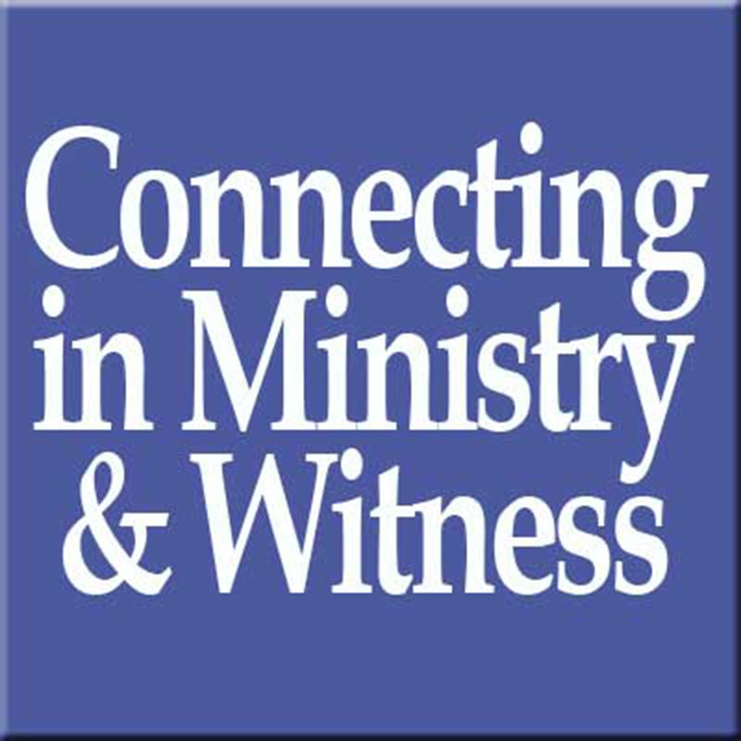
Rocky Mountain Synod Events

