2020 Rocky Mountain Synod Theological Conference Journal

WELCOME
Welcome to a journey that will ask us to look back and forward and deep. You may decide to write your reflections right here, as you go. If a digital journal is more your style, a Word version is available on the Theological Conference Website. All of the links listed in the meditations are also listed there. We have tried to pair these with some of the material that our presenters will be covering but, at the end of the day, this is for you to use in whatever way you choose.
Blessings on your reflections!

Monday Morning, September 21, 2020

Food for Thought:
Race in America; Creator of VeggieTales explains systemic racism
View Video Here
Questions to reflect on:
Phil Vischer created VeggieTales. His voice was Bob the Tomato. As the church muddles through trying to understand and see systemic racism, this short video makes a good attempt at drawing the outlines of how it came to be. If you could sit down with Phil, what would you want to question or challenge him on? What things touched you emotionally? Why do you think that was? Sit with that for a few minutes. Don’t rush it or judge it. Just be with those reflections.

Prayer:
Creator God, you created us in your image. Your Son came that we might continue to be transformed into that image. Such knowledge is too much for our small minds to contain and yet we try. As a community it has slipped between our fingers. Let our lives be mirrors of your image for one another, that we will see ever more truly who we are and whose. Amen.
Action:
Take a box of crayons out and find the crayon that matches best your skin tone. What’s it called? What is the most beautiful thing you have seen that is that color? Using the empty space below, make a picture of it, just for you.

Monday Afternoon, September 21, 2020

Food for Thought:
Matthew 6: 33-34. But seek first his kingdom and his righteousness, and all these things will be given to you as well. Therefore do not worry about tomorrow, for tomorrow will worry about itself. Each day has enough trouble of its own. (NIV)

Questions to reflect on:
As we enter these days of theological conference, what are the preoccupations, the tasks and responsibilities that are filling your conscience? What screams or whispers from the corners of your mind, asking that you pay attention to them? If there is something really important, attend to it, and welcome it to accompany you this week by writing it below.

But what about the rest of those things? Can you leave them with God for this time? If so, write them, one by one in the blank space on the right. Cut them into individual strips and and put them all in an envelope. Seal it. Pray as you hold it in your hands.

Prayer:
God of my preoccupations and intentions, free me from worry about tomorrow and the days after tomorrow. Help me to leave my concerns for various obligations in your hands for this time of learning and fellowship. Let this be a time of renewal for my spirit; of transformation from brokenness toward wholeness in Christ. In Jesus’ name, Amen.
Action:
Now go hide the envelope, out of sight, out of mind. In a closet or a under your bed or on top of the kitchen cupboard. Make them hard to reach, so that you can intentionally be present to what the Lord may say to you over the course of this conference. Don’t worry, we’ll remind you to check on them later.

Tuesday Noon, September 22, 2020

Food for Thought:
White Privilege: Unpacking the Invisible Knapsack - Peggy McIntosh
Here is an article with a list of 50 ways you might see the privilege you have taken for granted. If you are a person of color, this is a good time to take the gift card for Starbucks and go treat yourself to a favorite beverage. The rest of us are just catching up.

Questions to reflect on:
There are many excuses used to minimize the reality of privilege. Privilege or lack thereof is intersectional. Crystal M Fleming rants about how the black women joined the Black men’s liberation movement, only to be secondhand members. And they joined the women’s liberation movement only to be marched over by white sisters. List below the points of privilege on McIntosh’s list that you can relate to or other points of privilege that surfaced:

Prayer:
Lord, we have heard so many heavy things about the history of race in this land. At times I feel like Peter, shrinking away from you in the boat; unworthy to be in your presence. And sometimes, I just want to turn around and run away from all that it might demand of me. Guide my steps, Lord. Help me to turn from the image of myself that we have created. Lead us back to you.

Action:
Who are you besides white? Take a walk listing, one after another, all the various identifiers you claim for yourself. Spend a half block or so with each one. Give thanks for the layers of who you are and for our creator. Alternatively, write or doodle the identifiers in the image below.

Tuesday 3:30pm, September 22, 2020

Food for Thought:
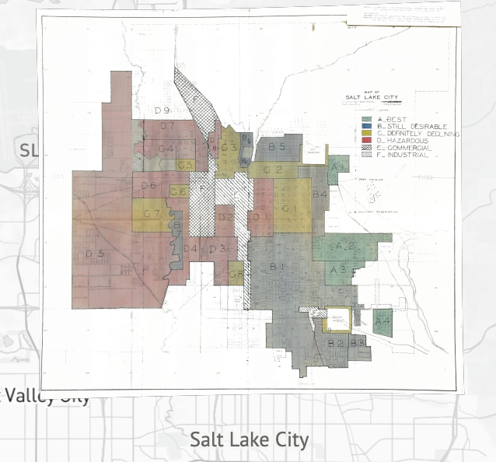
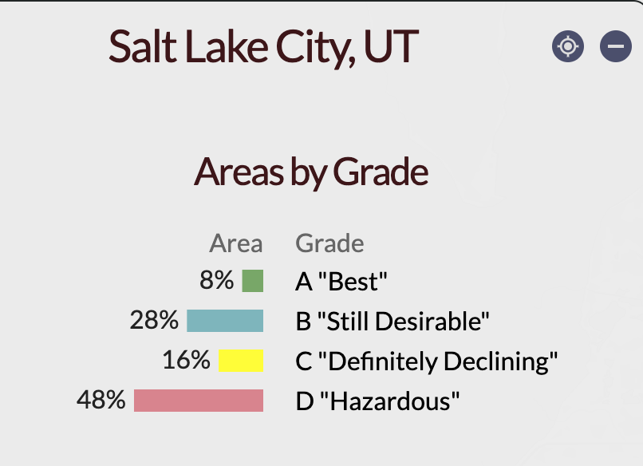
Where Do You Live? What is the history of your neighborhood?
Long before gerrymandering district lines, redlining was a thing. In an important case brought by black citizens, the Supreme Court was asked to determine the scope and the constitutionality of the 1866 law, which stated “that all persons born in the United States and not subject to any foreign power ... are hereby declared to be citizens of the United States; and such citizens, of every race and color, without regard to any previous condition of slavery or involuntary servitude ... shall have the same right, in every State and Territory in the United States, to make and enforce contracts, to sue, be parties, and give evidence, to inherit, purchase, lease, sell, hold, and convey real and personal property, and to full and equal benefit of all laws and proceedings for the security of person and property, as is enjoyed by white citizens, and shall be subject to like punishment, pains, and penalties, and to none other, any law, statute, ordinance, regulation, or custom, to the contrary notwithstanding.” Jones et Ux. v. Alfred H. Mayer Co. et al. 1968. 392 U.S. 409, 423.

The following is from the Introduction to a project that studied the secret maps of the HOLC, 1935-40.

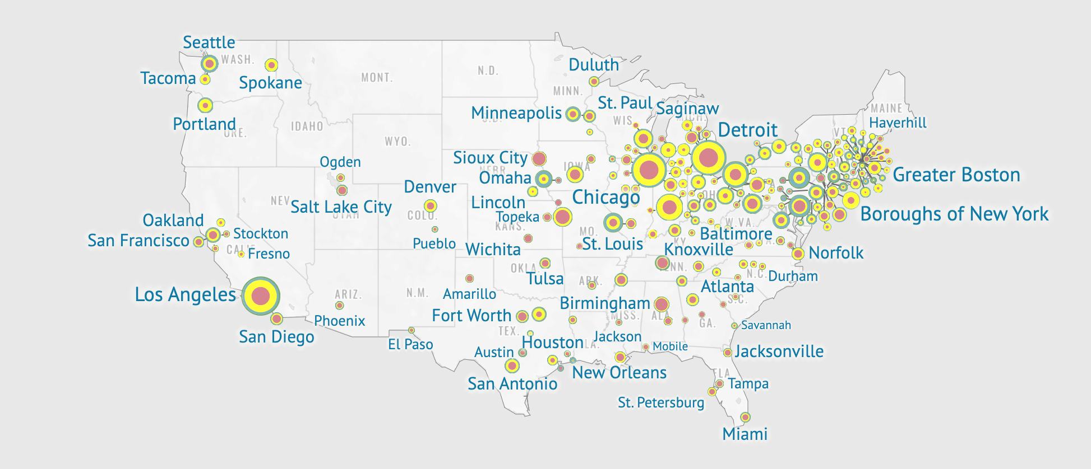
“In the 1980s discovery of the HOLC [Home Owner’s Loan Corporation] security maps changed the way historians thought about HOLC and New Deal housing policy. Housing activists in the 1960s and 1970s had criticized and protested discrimination in real estate lending and buying, coining the term “redlining” to illustrate the geographic dimensions of housing discrimination. Historian Kenneth Jackson found the maps in the National Archives, stating in his award-winning book Crabgrass Frontier that HOLC “devised a rating system that undervalued neighborhoods that were dense, mixed, or aging,” and rather than creating racial discrimination, “applied [existing] notions of ethnic and racial worth to real-estate appraising on an unprecedented scale.” Federal housing policy simply blocked African Americans from accessing real estate capital, leading to the creation of segregated mass suburbia and, neighborhood by neighborhood, opened residents to opportunity and wealth accumulation or closed citizens off from the American dream. Following Jackson’s work, historian Thomas Sugrue wrote of the legacy of federal housing policy in Detroit: “geography is destiny.” Outside of history, scholars and journalists, including sociologist Douglas Massey and writer Ta-Nehisi Coates, point to HOLC redlining as a key factor in racial disparities in wealth and opportunity that continue to the present day.” (Reference Link)
Questions to reflect on:
How might this have affected the generational wealth in my extended family? Were there stories told in my family about property, rentals or moving around neighborhoods? Is there any part of this redlining that I probably would have agreed with? Why? How do we make injustice in the past right?

Prayer:
Lord, how did we agree to see these lands as less than? What is your vision for these areas we have labeled “hazardous”?

Action:
Check out the maps for cities in our synod. The links can we found on the Theological Conference website. Note: There were none given for cities in either Wyoming or New Mexico.

Wednesday Noon, September 23, 2020

Food for Thought:
Who are you reading?
An Islamic proverb says that a lot of different flowers make a bouquet.
Albert Einstein said, ““Somebody who only reads newspapers and at best books of contemporary authors looks to me like an extremely near-sighted person who scorns eyeglasses. He is completely dependent on the prejudices and fashions of his times, since he never gets to see or hear anything else.”

Questions to reflect on:
Check out your bookshelves, at home and at church, for real or from memory. Consider things you subscribe to digitally. How much of your library is thanks to “old white men”? What authors of diversity are represented on your bookshelves? Who is missing?

Prayer:
Lord, even as a young man, you questioned the scriptures and the scribes. Despite degrees and experience, keep me from leaning too much on my own understanding. Keep me from ever leading any of “these little ones” astray by my biases or blindspots. Increase in me the curiosity and the thirst for justice that might allow me to better understand your will.

Action:
Help us create a synod book list by adding authors of diversity you have read to the google doc on the conference website.
Below, Make a list of “what is missing” and books or authors that you will actively hunt for and read:

Wednesday Noon, September 23, 2020

Food for the Soul:
“We Dance” by Hope Boykin and Alvin Ailey.
Lay your journal aside for now and open yourself to expressing the emotions that may be weighing you down. Watch this video.

Action:
Join in the dance as the Spirit moves you. Don’t forget to breathe.

Prayer, especially for those of us who suffer the impact of racism:
I am not yet ready for the journey.
I am not yet interested in the path.
I am at the prayer before the prayer of forgiveness.
Give me the will to want to forgive.
Grant it to me not yet, but soon.
Desmond Tutu, The Book of Forgiving

Thursday Afternoon, September 24, 2020

Food for Thought:
All those things I left in God’s care on Monday
You have had 3 days without these responsibilities or preoccupations. Or maybe you haven’t? You can quickly retrieve the envelope that you hid on Monday and go right back to those concerns as if nothing happened in between. Or…you can sit with each one and see if you really need to.

Questions to reflect on:
As you read each one, consider its relevance today. If it is no longer that important, simply thank God for taking it off your plate. If it is still important, thank God for giving you a time away and ask for a new clarity and energy to take it back. If you are not sure, let God know you are willing but unsure. Wait for clarity.
Finally, take a few minutes to reflect on how/why your encounters these past days might ask you see those things in a different light.

Prayer and Action:
Holding all the strips in your hands, say the Lord’s Prayer, trusting in the power of the one who taught us to pray.

Friday, September 25, 2020

Questions for Reflection:
The New Normal suggests 5 ways to work toward becoming antiracist. They are explained in this video which you may want to find time to listen to.
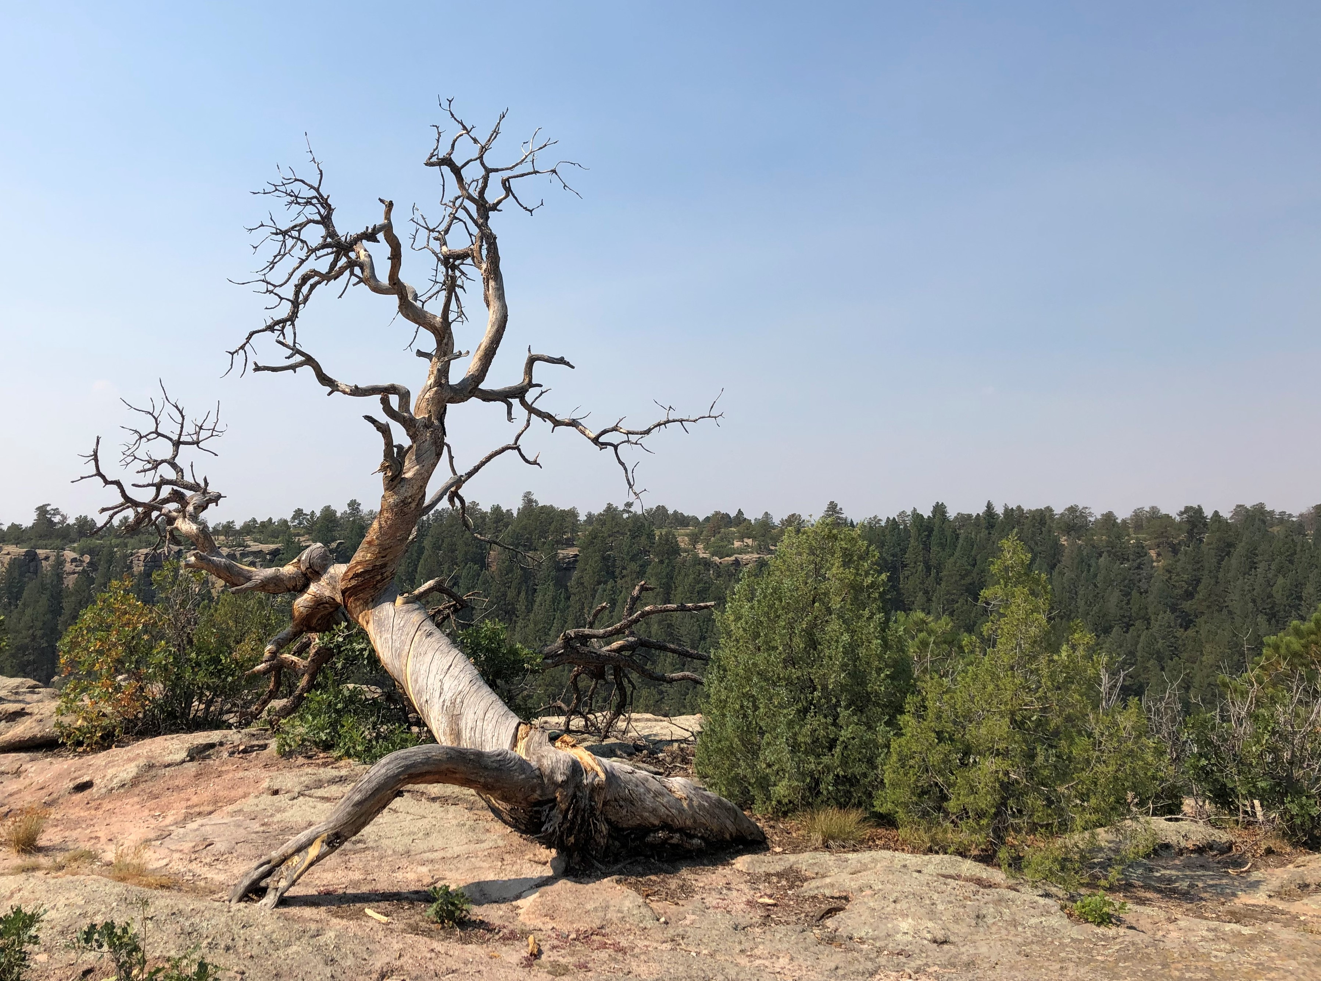
- Expect criticism-take it in, bite back the tears, and try not to be defensive.
- Be critical of your worldview.
- Educate yourself.
- Make anti-racism a way of life.
- Start at home- what networks do you belong to?

Can you name anything(s) that made you hopeful this week?
The point is, we hope you will take time to commit to where you want to go from here.

What are your lingering questions?

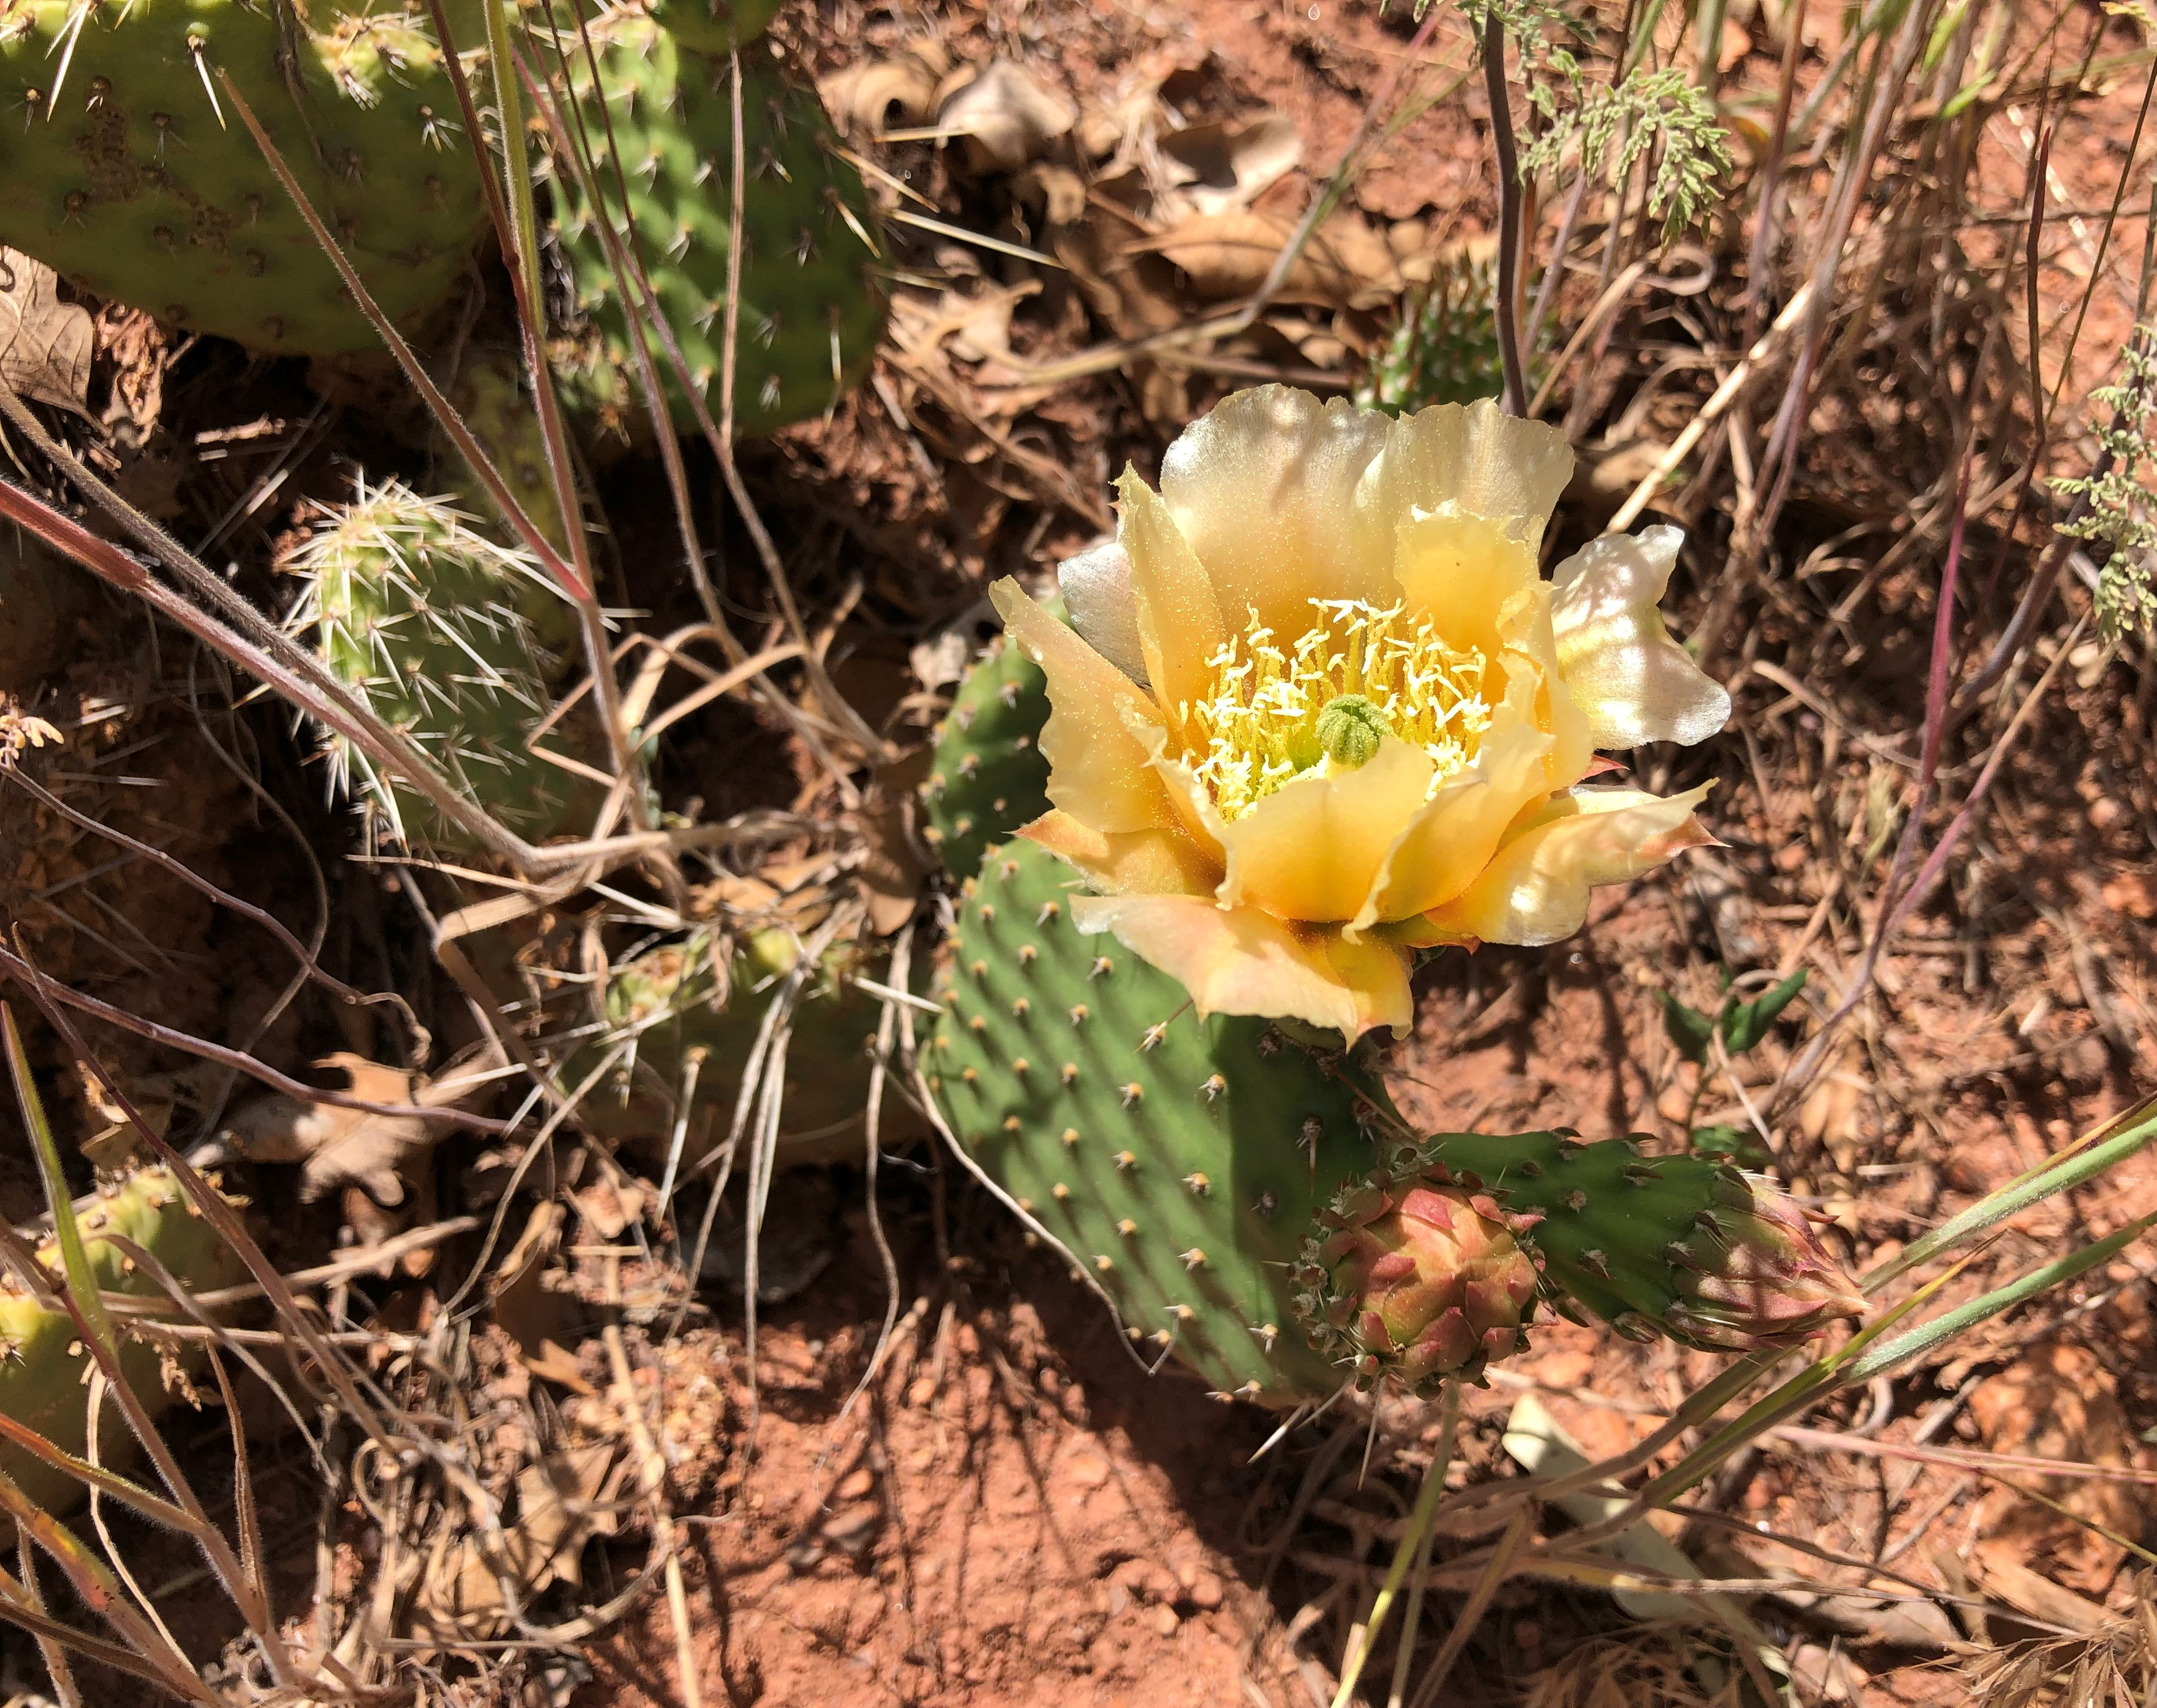
What are next steps for this process personally, or in the context of your work?

Who will partner with you? Will you ask a colleague or a neighbor to hold you accountable?

Prayer:
(by Kathryn Mary Lohre, Assistant to the Presiding Bishop, ELCA, p. 75, United Against Racism)
Prayer of Hope
Good and gracious God,
You have set us free from the slavery of our sin, including the sin of racism.
You have gathered your church together, united and freed in Christ.
You have bestowed us with treasures of diversity, blessings that too often we bend into burdens.
For we cling to- all of us, whether captivated by or held captive to- the sin of racism. This deadly “mix of power, privilege, and prejudice” keeps us divided from each other and from you.
O God, our God, we cry out to you that black lives matter.
We come before you, as the prophet Amos did in his time, calling out for your justice to roll down like waters. We cry out for the black lives that are degraded, diminished, demonized, divided, and destroyed, for as long as one cannot breathe, none of us can. The body of Christ is suffocating, and the church is complicit. Breathe your breath of life into us afresh.
Give us your wisdom to help us understand the complexity of racism and the compounding nature of oppressions. Give us your courage in our homes, schools, and communities as we teach our children to honor each person as made in your image. Give us your Pentecost vision of God’s people once scattered now gathered together as we seek to change and build more equitable systems and structures for all.
We are your people of hope- incarnate, in the flesh, - that God is with us, Emmanuel. This is the “hope that does not disappoint us.” This is the hope we long to embody to your world.
In Jesus’s name, Amen.

