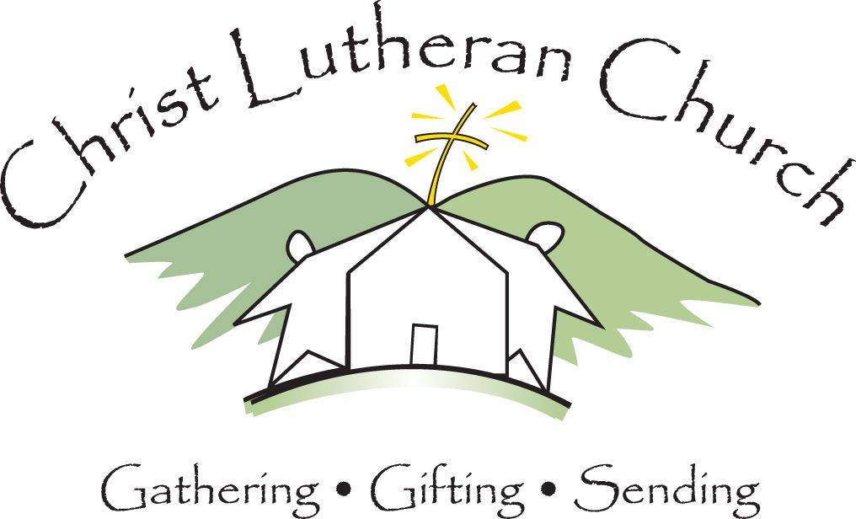

Christ Lutheran Church Job Description

Title: Office Coordinator
Reports To: Administrative Pastor
Employment Status:
Date: September 2016
Hours: 30/week

Position Summary:
The Office Coordinator provides office services for members of the church staff and various other committees and boards, tends to the organization of communications and keeps the records of the church.

Skills and Qualifications
- Demonstrated ability to maintain confidentiality and professionalism at all times
- Knowledge of standard office practices and techniques
- Proven organizational, time management and planning skills
- Skill in the use of personal computers and office equipment
- Proven interpersonal and communication skills both written and verbal
- Proficient with Microsoft Office Suite software
- Excellent typing and proofing reading skills
- Three to five years in a general office setting working with the public desired
- Proven organizational and record-keeping skills
- Working knowledge of office phone system
- Ability to work well in a team environment and participate collegially with staff members, pastors, and congregational leaders
- Self-motivated and able to function with minimal supervision

Duties and Responsibilities
- Membership
  - Responsible for all membership information in Church Community Builder and the Church Register; updates and maintains the parish register and parish records
  - Schedules and coordinates all baptisms, (i.e. fill out paperwork, letters, reminder phone calls, rose for person being baptized and passes information to Pastor and Director of Youth and Family Ministries)
  - Attends and presents membership information at new members’ classes

- Communications
- Answers requests regarding church activities, procedures and policies
- Preparation of monthly and weekly newsletter
- Responsible for communicating deadlines to staff and congregation
- Composes routine correspondance
- Responsable for phone maintenance and recording new messages
- Acts as pastoral liaison
- Work with staff to keep online presence up to date

- Worship Support
- Produces weekly response sheets and announcements
- Coordinates and produces bulletins for all services, (i.e. input liturgy, music, readings and prayers - compile and input calendar, special events, in-service individuals, small group information and upcoming activities)
- Place finished bulletins in the kitchen on Fridays along with the Children’s bulletins and attendance sheet for the Worship Teams

- General Church and Office Administration
- Responsible for opening the church office – office hours are Monday through Friday 8:30 a.m. to 4:00 p.m
- Manage general church office functions
- Provides receptionist services for the church office in conjunction with volunteer receptionists
- Records clear and accurate messages
- Greets and meets visitors
- Answers requests regarding church activities, procedures and policies
- Stocks new devotionals every three months in the Narthex
- Attends and participates in staff meetings
- Generates the annual ELCA reports
- Generates the semi-annual CLC reports and transmits them to the Rocky Mountain Synod
- Maintains inventory of office and sanctuary supplies and reorders as necessary and/or directed by the Operations Pastor
- Changes the sanctuary candle weekly
- Coordinates and distributes weekly staff agendas including anniversary celebrations and devotions and records staff meeting minutes
- Maintains Council minutes and materials necessary for council orientation
- Organizes logistics for staff and council retreats, manages building use requests, bringing items to staff attention, but not making definitive decisions in regards to new ministries
- Maintains the online calendar and event requests
- Works with Facilities Coordinator to schedule maintenance and repair events
- Maintain weekly attendance record
- Develops and prepares reports as requested
- Other tasks or projects as assigned

Americans with Disability Specifications

While performing the duties of this job, the employee is occasionally required to stand; walk; sit; use hands to finger, handle or feel objects, tools or controls; reach with hands and arms; climb stairs; balance; stoop, kneel crouch or crawl; talk or hear; taste or smell. The employee must occasionally lift and/or move up to 25 pounds. Specific vision abilities required by the job include close vision, distance vision, color vision, peripheral vision, depth perception and the ability to adjust focus.

