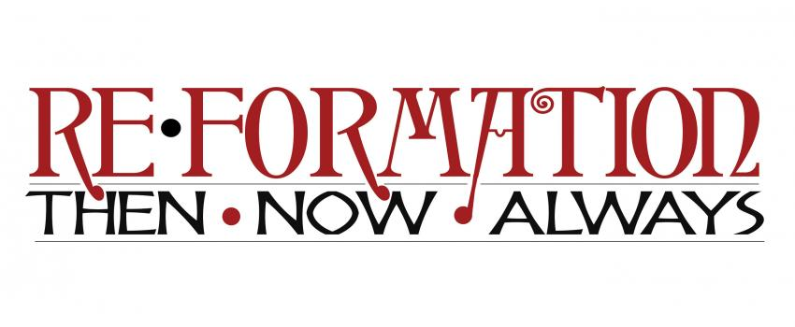

Rocky Mountain Synod Assembly — May 5-7, 2017

Re•Formation: Always

Session 1 Facilitator Guide

**THANK YOU** for your willingness to help lead assembly participants in this session! Below is a guide to the session and to the role of the facilitator. A *Re•Formation: Always* planning team member should be in the room with you, or close by, for any help needed during the session.

**Session 1 Theme**: “What does it mean to live out a Christian identity in the world?”

**Session 1 Goals:** 1) *meaningful small group conversation* that 2) builds trust and 3) invites participants to start reflecting on faith lived in the world, to prepare for 4) tomorrow’s conversations on ELCA social statements and the Small Catechism.

**Session 1 Overview:** After welcome and introductions, this session will have two main parts: 1) Bible Study and 2) Small group conversations with personal story sharing. At the end, you’ll wrap up and preview tomorrow’s session, in which we’ll put parts of Luther’s Small Catechism in conversation with some of the ELCA’s Social Statements.

**Session 1 Outline**

1. **Gather/Welcome (5 min.)**

Facilitator: Greet and welcome participants as they enter the room and encourage them to sit wherever they like around the tables. Copies of today’s Participant Guide with the Bible text and questions for discussion will be on the tables. Around five minutes after the start time, ask for the whole group’s attention, introduce yourself and welcome them officially to the session. Point them to the Participant Guide sheets on their tables and make sure everyone has a copy. Invite the tables to break up into smaller groups of 3-4 that will remain together for the rest of the session (encourage them to spread out as needed). Explain that you’ll be walking them through each step of the small group conversations.

1. **Introductions in small groups (1-2 min.)**

Facilitator: Ask your newly-formed small groups of 3-4 to take a few minutes to *briefly* introduce themselves to one another (Name, Congregation, Location).

1. **Introduction to goals for Re•Formation: Always Session 1 (1-2 min.)**

Facilitator: Invite the whole room to read along on their Participant Guide sheet as you read aloud the introductory paragraph and the guidelines for healthy conversations below. Take a moment to invite and answer clarifying questions.

*Introduction:* On behalf of the *Re•Formation: Always* planning team, welcome! As we continue to reflect on the 500th anniversary of the Reformation, we’re asking what it means to be a Lutheran Christian today, and how we live out that Christian identity in our daily lives in the world. We’ll ground our conversations in Bible Study and share some stories with one another in small groups. More than anything, the goal of this session is *meaningful conversation*.

*Guidelines for healthy conversations:* Many of you have lots of experience being in small groups (or with other people, in general), so just a few reminders: please strive to make sure every person in your group has a chance to be heard. Please strive to listen and respond to one another with kindness and respect. When (not if!) you disagree with someone, please first seek to understand their position and perspective better. And please, before you share publicly what someone else has shared in your small group (either online or face to face), ask them if it’s ok. This concludes our healthy conversation announcement. Now we return to our regularly-scheduled programming. ☺

1. **Guided *Lectio Divina* Bible Study – Luke 10:25-37 (15 min.)**

Facilitator: *Lectio Divina* is a practice for small groups to read and reflect together on a scripture text, typically by reading the same text several times and responding each time to guiding questions. Explain that each small group will read and discuss the text in their groups (encourage brief answers—there will be more conversation in the next part of the session.) Allow the groups to lead themselves, but offer a gentle reminder to move on to each next step after approximately five minutes.

*Step 1:* Invite one person in each small group to read the text aloud for their group and ask the group to answer the first question on the Participant Guide (“What word or phrase stuck out to you on the first hearing?”)

*Step 2:* Invite a different person in each small group to read the text aloud a second time and ask the group to answer the second question (“What character did you most identify with?”)

*Step 3:* Invite a third person in each small group to read the text aloud a third and final time, and ask the group to answer the third question (“What might Jesus be saying through this parable about living out our faith in the world?”)

*Step 4 (Facilitator):* 1-minute wrap up—take 60 seconds as a whole room and invite anyone to call out *one word or phrase* they consider a “takeway” from the Bible Study.

1. **Small Group discussion (30 min.)**

Facilitator: Invite participants to look at the introductory paragraph to the next part of the session, “Tell a Story,” and read this paragraph aloud:

*Tell a Story:* The story we just read is often called “The Parable of the Good Samaritan.” Jesus often taught in parables, which were short stories that placed the big questions and issues of faith alongside everyday examples from life. In this parable, Jesus asked his listeners to consider how to live out their faith in God by being a “neighbor.” Next, we’ll share stories from our lives that explore how we live out our Christian identity in the world every day.

Next, invite the groups to take the next half an hour for *each group member* to answer the following questions (encourage them to move on after each 10 minutes).

1. Who was someone in your life who modeled for you what it means to live out Christian identity in the world?
2. When and where in your life did you make a choice or take an action that was prompted by your Christian identity?
3. What is one way your congregation has lived out Christian identity in the world?
4. **Wrap Up/Preview (5-7 min.)**

Facilitator: Make sure to bring small group conversations to a close around 5-7 minutes before the end of the session time. Lead and share the following:

*2-minute Wrap-Up*: Invite anyone in the room to share *one word or phrase* they will take away from their small group conversations. What is one insight they have gained about living out Christian identity in the world?

*3-minute Preview:*

* Tomorrow’s session theme: Living the Catechism in the World
* For the 500th anniversary of the Reformation, Presiding Bishop Elizabeth Eaton has asked ELCA members to study Martin Luther’s Small Catechism—Luther’s clear and simple guide to what Christian faith looks like in everyday life. Tomorrow, you’ll have the chance to explore some of the texts from the Catechism and to connect them to some of the ELCA’s social statements—texts that the church has created to address how our Lutheran-Christian identity connects to some of today’s most pressing issues.
* In tomorrow’s session, we’ll ask you to choose ONE of the following topics: Church in Society; Peace; Economic Life; Race, Ethnicity and Culture; or Caring for Creation. Be thinking about which topic you feel most drawn to, or challenged by. We encourage you to check the Assembly app to find 1-page summaries of each social statement and links to the whole social statements as well as the Small Catechism.
* Tomorrow we’ll meet again back here in this room at our session time, and you’ll form small groups around your areas of shared interest.
* Look for Pastor Zach Parris at our “Re•Formation: Always” table and share what you’re learning in a short video interview!

**Go in peace, serve the Lord! Thanks be to God!**