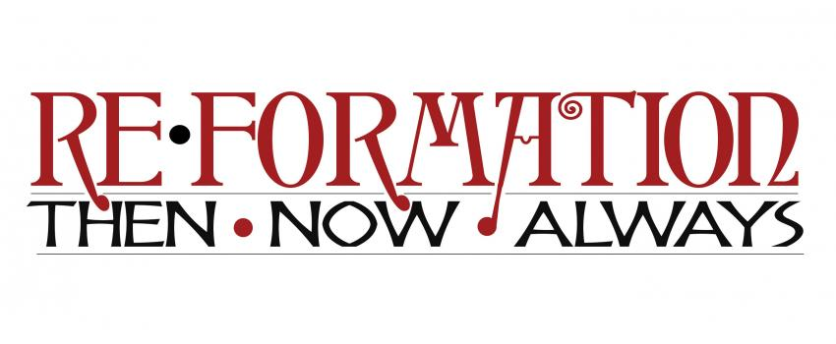
Rocky Mountain Synod Assembly — May 5-7, 2017

Re•Formation: Always
Session 2 Facilitator Guide

THANK YOU for your willingness to help lead assembly participants in this session! Below is a guide to the session and to the role of the facilitator. A Re•Formation: Always planning team member should be in the room with you, or close by, for any help needed during the session.

Session 2 Theme: “Living the Catechism in the World”

Session 2 Goals: 1) meaningful small group conversation (even in disagreement!) that 2) builds trust and 3) invites participants to continue reflecting on faith lived in the world through 4) ELCA social statements and the Small Catechism.

Session 2 Overview: After welcome and introductions, session will have three main parts: 1) Exploring the Catechism, 2) Exploring the ELCA’s Social Statements, and 3) Putting it all together. Participants will meet in small groups (each small group will focus on only ONE of the following topics: Church in Society; Peace; Economic Life; Race, Ethnicity and Culture; or Caring for Creation.)
Participant Guides for each topic will be provided with texts from the Small Catechism, a summary of the ELCA Social Statement, and questions to guide discussion. Your role (outlined below) will be to guide the small groups through each step and to help them make connections in the large group.

Session 2 Outline

- Gather/Welcome (5 min.)

Facilitator: Greet and welcome participants as they enter the room. Invite participants to take a copy of the Participant Guide for the specific topic they would like to discuss (Church in Society; Peace; Economic Life; Race, Ethnicity and Culture; or Caring for Creation) and find a seat. Around five minutes after the start time, ask for the whole group’s attention, introduce yourself and welcome them officially to the session. Make sure everyone has a copy of the Participant Guide for their chosen topic, and ask participants to form small groups of 3-4 people who have all chosen the same topic (tip: Identify a different area in the room for each topic. Ask participants to move to the area assigned to their topic, where they can then split into small groups.) Once the groups have formed, invite them to find seats together and to spread out as necessary.

- Introductions in small groups (1-2 min.)

Facilitator: Ask your newly-formed small groups of 3-4 to take a few minutes to briefly introduce themselves to one another (Name, Congregation, Location).
- Introduction to goals for Re•Formation: Always Session 2 (5 min.)

Facilitator: Invite the whole room to read along on their Participant Guide sheet as you read aloud the introductory paragraphs below and the guidelines for healthy conversations. Take a moment to invite and answer clarifying questions.

Introduction: On behalf of the Re•Formation: Always planning team, welcome! As we continue to reflect on the 500th anniversary of the Reformation, we’re asking what it means to be a Lutheran Christian today, and how we live out that Christian identity in our daily lives in the world. Today’s session will focus on connecting our Christian identity to specific areas of life together in the world. Like yesterday, the goal of this session is meaningful conversation.

What is the Small Catechism? Martin Luther wrote the Small Catechism almost 500 years ago in the hope that households would read it together as a guide to faith in daily life. Luther intended the Catechism to be simple and clear, easy to read and understand. Overall, the Catechism was grounded in two assumptions: 1) God is present with us in the world everywhere and always, in everything we do and 2) Every person—no matter how we spend our day—has a vocation, a holy calling, to serve God in our daily work and relationships, as citizens, neighbors, and friends.

What are the ELCA Social Statements? “ELCA social statements are teaching and policy documents that provide broad frameworks to assist us in thinking about and discussing social issues in the context of faith and life. They are meant to help communities and individuals with moral formation, discernment and thoughtful engagement with current social issues as we participate in God’s work in the world. Social statements also set policy for the ELCA and guide its advocacy and work as a publicly engaged church. They result from an extensive process of participation and deliberation and are adopted by a two-thirds vote of an ELCA churchwide assembly.” (www.elca.org/faith/faith-and-society/social-statements)

Guidelines for healthy conversations: A few reminders: please strive to make sure every person in your group has a chance to be heard. Please strive to listen and respond to one another with kindness and respect. When (not if!) you disagree with someone, please first seek to understand their position and perspective better. And please, before you share publicly what someone else has shared in your small group (either online or face to face), ask them if it’s ok.

- Small Group discussion: Small Catechism and Social Statements (40 min.)

Facilitator: Ask small groups to turn to their Participant Guides, where they will find the one-page summary of the ELCA social statement for their chosen topic (Church in Society; Peace; Economic Life; Race, Ethnicity and Culture; or Caring for Creation) and instructions for reading and discussing the social statement summary together. Allow groups to self-guide Parts 1, 2, and 4, but interrupt to move groups along for each part of the discussion. Lead Part 3.

Part 1: Social Statements (10 min.)

- In each small group, one or more volunteers will read the social statement summary aloud while the other group members follow along.
- After the statement summary is read, each group member shares: What did you notice? What did you wonder?

Part 2: Small Catechism (10 min.)

- In each small group, one or more volunteers will read the excerpts from the Small Catechism aloud while the other group members follow along.
- After the texts from the Catechism are read, each group member shares: What did you notice? What did you wonder?

Part 3: Large Group Check-In (10 min.) – Participant Leads

- Five-minute check-in: invite anyone to share with the whole group one thing they noticed, or wondered, in their small group time.
- Introduce final part of discussion:
“Martin Luther’s most famous question, taken from the Catechism, is “what does this mean?” As Luther continually asked this question, now we’ll ask this together: reflecting on the sessions yesterday and today, and our theme of living out Christian identity in the world, what does this mean?”
- Invite participants to return to small groups for Part 4.

Part 4: What Does This Mean? (10 min.)

- What does this mean for me (as a Lutheran Christian)?
- What does this mean for my congregation?
- What does this mean for the church?

- Wrap Up (5-7 min.)

Facilitator: Make sure to bring small group conversations to a close around 5-7 minutes before the end of the session time. Lead and share the following:

3-minute Wrap-Up: Invite anyone in the room to share one thing they will take away from their small group conversations. What is one insight they have gained about living out Christian identity in the world?

Thank-You: Please thank group for their willingness to participate, share, trust each other and share respectful and faithful conversation!

Encouragement: Encourage participants to keep exploring the Small Catechism and Social Statements, to share their experience of these sessions with their congregations in a newsletter article or temple talk, and to consider where else in their lives and the world they are called!

Closing Prayer (Invite participants to pray together aloud): Gracious God, in Jesus Christ you lived among your people in the world, teaching compassion, justice and peace. In Christ you were crucified, died, and rose again. Through the Holy Spirit, you make us into Christ’s body through baptism, and you send us into the world with a holy calling every day. Help us and guide us in your grace, so together we may continue to do your work with our hands. In Jesus’ name, Amen.

Go in peace, serve the Lord! Thanks be to God!

