Youth Gathering | Synod Assembly | Theological Conference
January 13-15, 2018  Doubletree Hotel  Colorado Springs, CO | May 3-5, 2018  Westin Hotel  Westminster, CO | September 17-20 2018  YMCA of the Rockies  Estes Park, CO  Single:$510  Double: $360  Triple: $300
January 2019 (Proposed)  YMCA of the Rockies  Estes Park, CO | May 3-5 2019  Friday-Sunday  Embassy Suites  Albuquerque, NM  Registration: $300  Hotel: $119-129 | October 7-10, 2019 (Confirmed)  YMCA of the Rockies  Estes Park, CO  Single: $500  Double: $350  Triple: $300
January 2020 (Proposed)  Albuquerque, NM | May 1-3, 2020  Conference/Regional Assemblies | September 2020 (Proposed)  Sante Fe, NM  Single: $550  Double: $400 destrada@rmselca.org
January 2021 (Proposed)  Colorado Springs, CO | May 2021 (Proposed)  Embassy Suites  Loveland, CO | September 2021 (Proposed)  Little America Hotel  Cheyenne, WY
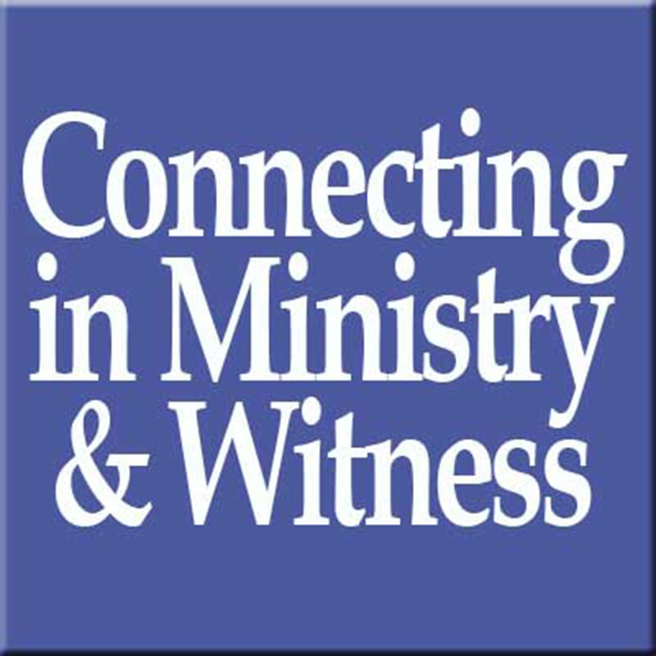
Rocky Mountain Synod Events
- The proposed rotation for the Youth Gathering is meant to reflect a rotation similar to synod assembly and theological conference: South Colorado, North Colorado/WY, non-Colorado (NM, UT).
- In years we are not in Colorado, less travel equalization reimbursement is not available due to the higher number of congregations/leaders traveling, which increases the cost of the event for congregation and ministries attending.
- For this reason, the 2020 Theological Conference in Sante Fe is proposed for a different fiscal year than the 2019 Assembly in Albuquerque.
- The reason for proposing both the 2018 and 2019 Theological Conference at the YMCA of the Rockies is that the lower cost of this facility will allow us to reduce the registration cost. Our hope is that these savings will help leaders prepare for the higher cost of the 2019 Assembly and 2020 Theological Conference.

