Synod Assembly | Conference Gatherings | Theological Conference
May 1-3, 2019  Embassy Suites  Albuquerque, NM | 2019  Excellence in Leadership  Stewardship for All Seasons | October 7-10, 2019  YMCA of the Rockies  Estes Park, CO  Single: $520  Double: $370  Triple: $320
May 1-2, 2020  Regional Assemblies  Ascension St. Matthew's, Price, UT  Ascension, Cheyenne, WY  Cross of Christ, Broomfield, CO  Trinity, Monument, CO  Cross of Hope, Albuquerque, NM  Registration: $225  Hotel: TBD | Fall 2020  Conference Better Together Summits selected from 1 of 5 options created at 2020 Assemblies | September 21-24, 2020  Marriott Hotel  Colorado Springs, CO  Single: $590  Double: $430  Commuter: $275
April 29-May 1, 2021 (Confirmed)  Embassy Suites  Loveland, CO  Registration: $310  Hotel: $119-129  Breakfast included | Fall 2021 | September 19-22, 2021  Little America Hotel  Cheyenne, WY  Single: $660  Double: $465  Commuter: $275
May 2022 (Confirmed)  El Paso Convention Center  El Paso, TX  Registration: $310  Hotel: $129 | Fall 2022 | September 2022 (Proposed)  YMCA of the Rockies  Estes Park, CO
May 2023 (Proposed)  Keystone, Pueblo, or Regional Assemblies | Fall 2023 | September 2023 (Proposed)  Salt Lake City, UT
May 2024 (Proposed)  Embassy Suites  Loveland, CO  **Bishop Election** | Fall 2024 | September 2024 (Proposed)  YMCA of the Rockies  Estes Park, CO
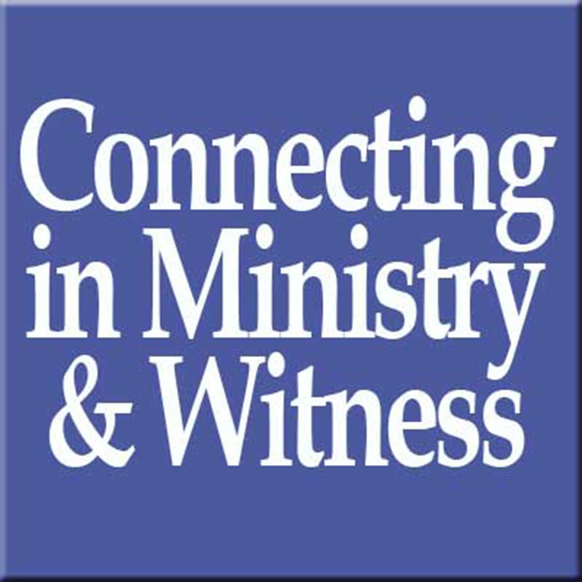
Rocky Mountain Synod Events

Synod Assembly | Fall Conference Gatherings | Theological Conference
May 1-3, 2019  Focus: Be Transformed | Fall 2019  Excellence in Leadership  Stewardship for All Seasons | October 7-10, 2019  Estes Park, CO  Theme: Be Transformed  Focus: Healthy Communities/Relationships
May 1-2, 2020  Regional Assemblies  Theme: Church Becoming  Focus: Church in Context | Fall 2020  Conference Better Together Summits selected from 1 of 5 options created at 2020 Assemblies | September 21-24, 2020  Colorado Springs, CO  Focus: Racism and White Privilege
April 29-May 1, 2021  Loveland, CO  Theme: |  | September 2021 (Pending)  Cheyenne, WY  Focus: Preaching & Worship?
May 2022 (Pending)  El Paso, TX |  | September 2022 (Proposed)  Salt Lake City, UT  Focus: Faith & Science?
May 2023 (Proposed)  Keystone, Pueblo, or Regional Assemblies |  | September 2023  Estes Park, CO  Focus:
May 2024 (Proposed)  Embassy Suites  Loveland, CO  **Bishop Election** | Fall 2024 | September 2024 (Proposed)  YMCA of the Rockies  Estes Park, CO

