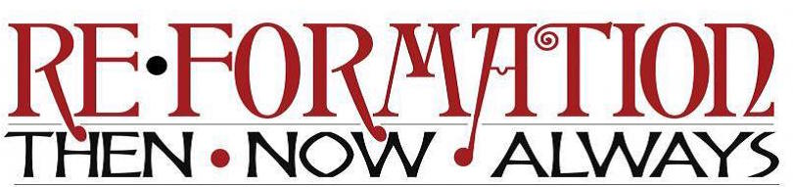

Saturday Afternoon Sessions
Each afternoon session will open with a history and overview of the ELCA’s six full-communion relationships and conversation with a Rocky Mountain Synod pastor. Following the introduction, a local full-communion clergy will share their church’s Reformation story. The final portion will include a story and conversation with a Rocky Mountain Synod congregation currently engaging in full-communion partnership ministry.

Ecumenical Community Ministry and the United Methodist Church
(First United Methodist Church)
Rev. Kent Ingram: Methodist Reformation/Wesleyan Tradition
Rev. Paul Rosin: Full-communion partnership for ministry in the community; learn about the ecumenical prison ministry in Delta County and how congregations and leaders in Austin, CO have joined together to establish an overnight shelter.

Serving in a Full-Communion Context and the Episcopal Church
(Grace and St. Stephens Episcopal Church)
Rev. Jeremiah Williamson: The English Reformation/Anglican Church
Rev. Kim Gonia & Rev. Quirino Cornejo: Serving a full-communion congregation; hear the stories of a Lutheran pastor serving an Episcopal congregation and an Episcopal priest serving an ELCA Latino congregation in Denver, CO.

Doing Church Together and the United Church of Christ
(On-site at Antlers Hotel- limit 100 people)
UCC Representative
Rev. Leslie Wood (UMC), United Church of the San Juans: doing church together as a joint Lutheran-Methodist-Presbyterian-United Church of Christ congregation in Ridgeway, CO.

Forming a joint witness and the Presbyterian Church (USA)
(On-site at Antlers Hotel, limit 100 people)
Rev. Dr. Robert Leivers, Pueblo Presbytery
Rev. Kristi Koppel: Navigating the waters of full-communion partnership; hear the story of how a Lutheran congregation and Presbyterian congregation are beginning the journey toward a joint witness in Alamogordo, NM.

