Summarized Biography:

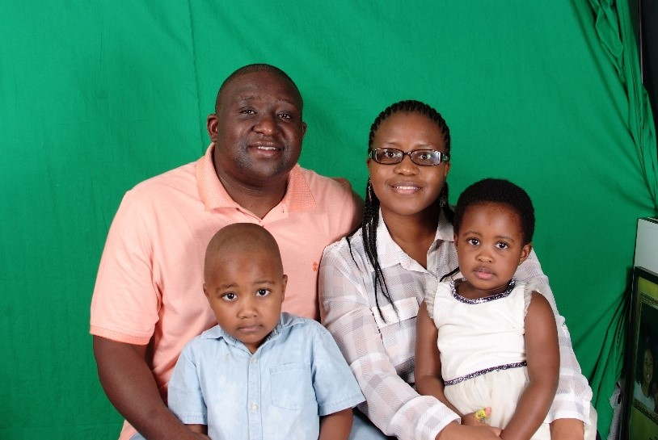

Rev. Lancelot Themba Mkhabela has been serving as the ELCA Global Mission Regional Representative for Madagascar, West and Central Africa (MWCA) for the last six years. Themba and his wife, Kwena, and their two children, Thando (5years old) and Tumisho (3 years old) reside in Antananarivo, Madagascar.

Themba is a graduate of the Pacific Lutheran Theological Seminary in Berkeley, California. After seminary, he serviced as a Pastor for an ELCA congregation, the Lutheran Church of the Reformation on St. Thomas in the U.S. Virgin Islands for six years prior to accepting his current call. While serving in the Virgin Islands he had an opportunity to serve in the Synod Council of the Caribbean Synod and Board of Trustees of Lutheran Theological Southern Seminary in Colombia, SC. He was also the Dean of the Virgin Islands District of the Caribbean Synod for three years.

In his current position he is responsible for the ELCA engagements in Madagascar, Nigeria, Sierra Leone, Ghana and Liberia on behalf of the ELCA Area Director. He also serves as a resource person for theological education for ELCA companions in the region on behalf of the Area Director. In addition to the countries already listed the MWCA region also includes the Central Africa Republic, Cameroon, Senegal, Rwanda and the Gambia.

Themba has long connections to the Rocky Mountain Synod. After his arrival in the USA from South Africa in 2000, he joined Bethany Lutheran Church in Colorado Springs, Colorado. Later Bethany merged with Our Savior Lutheran Church to create a new Congregation. He also did his candidacy process for ordained ministry in the RMS. His seminary education was partly supported by the South East Colorado Conference of the RMS. Themba has a background in culinary arts, he received culinary training from South Africa, London and the Broadmoor Hotel in Colorado Springs. It was the combination of his culinary skills and the support of congregations in the RMS which put him through seminary. During summer holidays when he was in seminary he used to return to Colorado Springs to cook for congregations in the conference to raise funds for seminary. He and his wife kwena, love to cook and to entertain. This is a gift which remains useful even in his current call.

He is very happy to be rostered in the RMS, it is like coming home. He looks forward to continuing to assist the Synod in any way possible to support the RMS’s companionship with the Synods of the Malagasy Lutheran Church.

