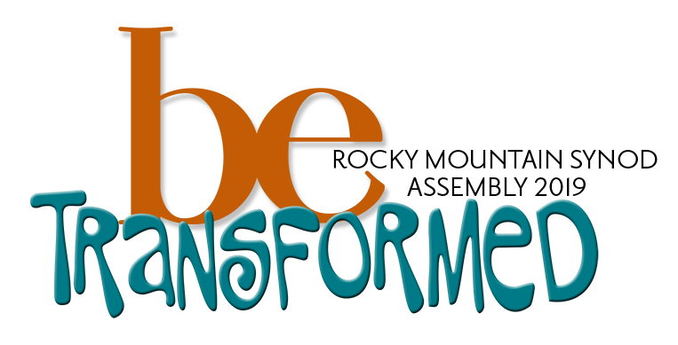

Worship Resources for Congregations

Synod Assembly Weekend

May 4-5, 2019

Dear Rocky Mountain Synod Leaders,
During the weekend of May 3-5, 2019 we will be gathering in Albuquerque NM as Christ’s people of the ELCA Rocky Mountain Synod under the theme “Be Transformed”. While the language of transformation does not always come easily to Lutheran Christians, rooted as we are in the paradox of living simultaneously as sinner and saint, our own baptismal theology points us to the daily transformation that takes place when Christ’s unfailing love puts to death our fear and need to control, judge and defend, and raises us to live as God’s beloved children, freed to serve neighbor and world in joy. We are grateful that Father Richard Rohr from the Center for Action and Contemplation will be our keynote speaker, helping us explore the connection between our inner lives, our call to service and the kind of transformation God’s grace makes possible in us and in our world.

The timing of this particular Assembly over a weekend is designed to assist our lay voting members who might otherwise have to take additional time away from work to participate. Given that most of our rostered ministers, including congregational pastors, will be at the Assembly, we are offering this packet of resources and invite your congregation to use them over Assembly weekend as a sign of our life as Christ’s Church, Better Together. The enclosed liturgy and a sermon reflect the worship that will be taking place at our Assembly.

Congregations whose pastor will not be present on the Saturday or Sunday of Assembly have a variety of options for worship leadership. Our RMS Supply List (found here: www.rmselca.org/pulpit-supply) offers the name of pastors who are available to serve in your area. This is a great opportunity for area ELCA congregations to join together for worship. This is also an ideal time to invite an ordained leader from one of our full communion churches to preside. Congregations that do not have an option for pastoral leadership may wish to use the Service of the Word option from our enclosed liturgy that includes a session of Centering Prayer. Centering Prayer is a spiritual practice that invites us to sit in stillness and silence in God’s transforming presence, praying with our being more than our words. While still relatively new to many Lutherans, this contemplative practice is finding increasing use in our own congregations and was made familiar by Father Thomas Keating from St Benedict’s Monastery in Snowmass CO. A guide to Centering Prayer is included in this packet.

However you may choose to gather for worship, we encourage you to celebrate our call to be Christ’s Church, Better Together! Please share your pictures and stories with us by posting on Facebook using the hashtag #rmschurchtogether and tagging the Rocky Mountain Synod. You can also email your pictures and stories to Deacon Erin Power: epower@rmselca.org

Yours in Faith,

Bishop Jim Gonia

Introduction to the resources
Our hope in offering these worship resources is to embody our commitment to being Church Together by worshiping together. Parts of the liturgy pieces in this packet are taken from the worship services taking place at the Synod Assembly. Other pieces are connected to the theme and keynote speaker. Please use all or portions of the liturgy as is possible and helpful to your context. If you have questions or need additional support, please contact Deacon Erin Power at the Office of the Bishop.
The liturgy is in the tradition of the ELW, based on our theme “Be Transformed, and written by Deaconess Sarah Bjornebo.

Creating the Circle
To open the 2019 Synod Assembly, those gathered will name and celebrate many of the people and stories that create the fullness of who we are as the Church Together: Native peoples past and present, our full-communion partners, our siblings in the Malagasy Lutheran Church, the congregations and ministries gathered at assembly, and the leaders in our church who have died this past year.
Who are the people, stories, and ministries that are part of your story and community?
- Who were the native peoples that originally lived on your land?
- What happened on your land before your community was there?
- Who uses your building now? Who do you partner with in ministry?
- What significant events happened in your community this year or in past years?
- What stories are still informing who you are as a community?
- Who are you connected to as the Church Together? (Rocky Mountain Synod, ELCA, Lutheran World Federation, Global Mission Partners)
As each person, ministry, or story is introduced, consider lighting a candle, ringing a bell, or offering a moment of silence. Additionally, you could create space for worshippers to create the circle: lighting a candle, writing names and ministries on a large poster, bringing in objects, etc.

Confession and Forgiveness
As people of God, we are committed to transformation and increased justice. This justice must begin with naming our own participation in injustice. The language in confession and forgiveness is based on commitments of the church stated in 4 documents:
- Rocky Mountain Synod Memorial: Repudiation of the Doctrine of Discovery,
- ELCA Social Policy Resolution: Repudiation of the Doctrine of Discovery;
- ELCA Worship Resource: Confession, Repentance, and Commitment to End Racism
- ELCA Social Message on Immigration

Offering
An offering will be taken at Synod Assembly for Betela Seminary in Madagascar. The students and faculty from Betela have shared a song to play during offering. This video is available at www.vimeo.org/rmselca. Another option is to collect your offering “Malagasy style”, with a central offering basket and the congregation comes to the altar to bring their offering forward.
Sermon
A sermon from Bishop Gonia will be available in both video and written form.

Centering Prayer
One option for a Service of the Word, or as an addition to your Eucharistic worship, is a time for centering prayer. Background and guidelines for centering prayer is available with this worship resource packet.

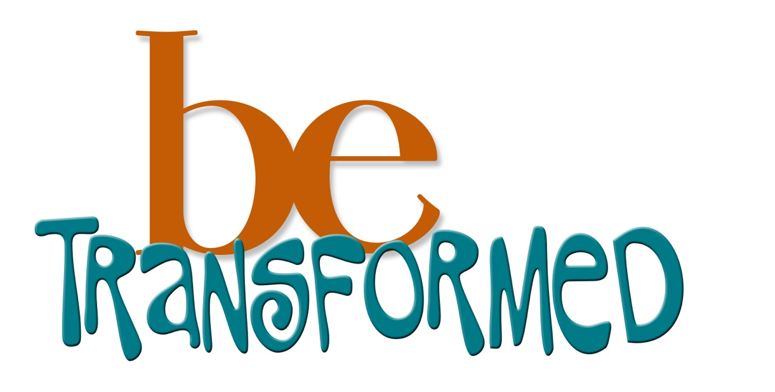

Congregations of the Rocky Mountain Synod
Third Sunday of Easter
Worship with Holy Communion
OR
Service of the Word with Centering Prayer

Welcome!
Dear Beloved of the Rocky Mountain Synod,
While you are worshipping in your community, members of the Rocky Mountain Synod are gathering in Albuquerque, NM under the theme “Be Transformed”. While the language of transformation does not always come easily to Lutheran Christians, rooted as we are in the paradox of living simultaneously as sinner and saint, our own baptismal theology points us to the daily transformation that takes place when Christ’s unfailing love puts to death our fear and need to control, judge and defend, and raises us to live as God’s beloved children, freed to serve neighbor and world in joy. The liturgy that follows models the worship happening our Synod Assembly and is being celebrated in congregations across the RMS this weekend, so that we are worshipping as the Church Together! Through prayer, worship, and conversations, I invite you to explore as a community how God is inviting you to Be Transformed for the sake of the world!
Yours in Faith,
Bishop Jim

Invocation/Call to Worship
P: Come, Holy Spirit, Come!
Come, Holy Spirit! Come!
P: Breath of God, Breath of Life, Breath of our deepest yearning,
Come, Holy Spirit!
P: Comforter, Disrupter, Interpreter, Inspirer,
Come, Holy Spirit!
P: Holy Justice, Revealer of Truth, Midwife of Change
Come, Holy Spirit!
P: Blessed be the Holy Trinity, + one God, who creates us and forms us, who redeems us and calls us, who unites us and sends us
Amen

Confession
As people of God, we are committed to transformation and increased justice. This justice must begin with naming our own participation in injustice. The language in confession and forgiveness is based on commitments of the church stated in 4 documents: Rocky Mountain Synod Memorial: Repudiation of the Doctrine of Discovery, ELCA Social Policy Resolution: Repudiation of the Doctrine of Discovery, ELCA Worship Resource: Confession, Repentance, and Commitment to End Racism, and the ELCA Social Message on Immigration
P: Gathered in God’s presence, let us confess our sin
P: God of light and life,
we confess that we are captive to sin and cannot free ourselves.
We seek our own way. We divide the body of Christ. In your mercy, cleanse us and heal us.
(silence)
P: We confess with our Native siblings that the whole of Creation is God’s work and God’s Spirit dwells within in all that God has made. We confess the sins of our ancestors and we acknowledge the damage done to the indigenous inhabitants of the Americas by European migration to the “New World.” We confess that our “New World” was already the homeland of many peoples. We confess the sin of dispossession.
In your mercy, cleanse us and heal us.
(silence)
P: Gracious God, we thank you for making one human family of all the peoples of the earth and for creating all the wonderful diversity of cultures. We confess the sins of racism. We confess the sins of our ancestors who allowed slavery in a country named for freedom. We acknowledge the damage done to all who were considered “less than” human because of the color of their skin or their ancestry. We acknowledge all of our choices and associations which promote or quietly condone injustice.
In your mercy, cleanse us and heal us.
(silence)
P: We rejoice that our church along with our country continues to change with the steady arrival of newcomers in the United States. As people of faith, we unite our hearts with all who wander in search of safety and a good home. We acknowledge the obstacles that our policies and culture create for immigrants, refugees, and asylum seekers. We confess all the ways we have benefited from the policies that have created poverty and desperation.
In your mercy, cleanse us and heal us.
(silence)
Forgive us, Gracious God,
Break down all that separates us from each other and from your love.
Empower us to speak boldly for justice.
Help us to see your image in the faces of all people.
Take away any arrogance or judgements which infects our hearts and bring us together as a transformed community, transfigured in the image of your love.
Enrich our lives by ever-widening circles of fellowship and show us your presence in those who differ most from us
In the name of + Jesus Christ, your sins are forgiven.
The joy of the Lord is your strength, and the gifts of the Holy Spirit are yours forever Amen

Gathering Hymn: Gather Us In (ELW 532)

Prayer of the Day
P: We pray together,
Holy God, you are beyond our knowing. Your glory is revealed in the face of Jesus Christ, and we see your image in every human being. Transform us into a new community. Transfigure us into the beauty of your holy people. Amen

Scripture
First Reading – Exodus 34:29-35:3
Second Reading – 2 Corinthians 3:12-4:2

Gospel Acclamation – ELW 172

Gospel: Luke 4:14-30

Sermon: Text and video sermon offered by Bishop Gonia

Hymn of the Day – Spirit of Gentleness (ELW 396)

Prayers
With the whole people of God in Christ Jesus, let us pray for the church, those in need, and all of God’s creation.
God of the universe, your creation is infinitely beautiful and beyond our wildest imagination.
You have blessed us with an intricate, fierce planet. Teach us to be wise caretakers of space. Teach us to tend the land with care and engage in sustainable practices. Heal our stubborn, selfish ways, and renew the earth with life.
We pray,
Have mercy, O God
God of our ancestors, we honor all of the saints and sinners who have come before us. May we tell their stories, and in telling their stories, may we learn our own.
We pray,
Have mercy, O God
God of the church, unite us. Heal the schisms of pride. Teach us to partner as equals for the sake of humanity. Transform our institutions and our ministries. Transfigure us into your holy people
We pray,
Have mercy, O God
God of change, calm our nerves and comfort our souls, as we embrace change in all facets of our lives. Teach us to be strong. Give us courage to daily face the realities of fear, pain, illness, violence, and death. Tonight we pray for . . and we remember aloud or in our hearts . .
We pray,
Have mercy, O God
God of community, be with us as we engage in these three days of Synod Assembly together. Open our hearts to someone new. Open our minds to a new idea. Open our souls to the possibilities.
We pray,
Have mercy, O God
Into your hands, gracious God, we commend all for whom we pray, trusting in your mercy; through Jesus Christ, our Savior.
Amen

Sharing of the Peace
A: The peace of God, which surpasses all understanding, will guard your hearts and your minds in Christ Jesus. The peace of the Lord be with you always.
And also with you.

Offering

Offering Prayer
P: Let us pray together:
Blessed are you, O God, maker of all things. Through your goodness you have blessed us with these gifts: our selves, our time, and our possessions. Use us, and what we have gathered, in feeding the world with your love. May the students, faculty, and staff of Betela Seminary know that in our prayers and with these gifts, we unite our spirits as partners in ministry. Bless the work of the Malagasy Lutheran Church. Transform us as we live in community. Amen.

Worship may continue with Holy Communion or Centering Prayer after the offering

MEAL

The Great Thanksgiving
P: The Lord be with you.
And also with you.
Lift up your hearts.
We lift them to the Lord.
Let us give thanks to the Lord our God.
It is right to give our thanks and praise.
It is indeed right, our duty and joy, that we should at all times and in all places give thanks and praise to you, almighty and merciful God, for the glorious resurrection of our Savior Jesus Christ, the true Paschal Lamb who gave himself to take away our sin; who in dying has destroyed death, and in rising has brought us to eternal life. And so, with Mary Magdalene and Peter and all the witnesses of the resurrection, with earth and sea and all their creatures, and with angels and archangels, cherubim and seraphim, we praise your name and join their unending hymn:

The Sanctus – ELW setting 8 (p. 190)

The Eucharistic Prayer and Words of Institution
P: Holy God, you alone are holy, you alone are God. The universe declares your praise: beyond the stars; beneath the sea; within each cell; with every breath.
We praise you, O God.
Generations bless your faithfulness: through the water; by night and day; across the wilderness; out of exile; into the future.
We bless you, O God.
We give you thanks for your dear Son: at the heart of human life; near to those who suffer; beside the sinner; among the poor; with us now.
We thank you, O God. Amen.

In the night in which he was betrayed, our Lord Jesus took bread, and gave thanks; broke it, and gave it to his disciples, saying: “Take and eat; this is my body, given for you. Do this for the remembrance of me.”

Again, after supper, he took the cup, gave thanks, and gave it for all to drink, saying: “This cup is the new covenant in my blood, shed for you and for all people for the forgiveness of sin. Do this for the remembrance of me.”

Remembering his love for us on the way, at the table, and to the end, we proclaim the mystery of faith:
Christ has died. Christ is risen. Christ will come again.

We pray for the gift of your Spirit: in our gathering; within this meal; among your people; throughout the world. Blessing, praise, and thanks to you, holy God, through Christ Jesus, by your Spirit, in your church, without end.
Amen.

The Lord's Prayer
Gathered into one by the Holy Spirit, let us pray as Jesus taught us:

Our Father, who art in heaven,
hallowed by thy name,
thy kingdom come,
thy will be done,
on earth as it is in heaven.
Give us this day our daily bread.
And forgive us our trespasses,
as we forgive those
who trespass against us.
And lead us not into temptation,
but deliver us from evil.
For thine is the kingdom,
and the power, and the glory,
for ever and ever. Amen.

Lamb of God – p. 182 (ELW setting 7)

Communion Hymns – ELW 801, ELW 315

The Communion Blessing
P : The body and blood of our Lord Jesus Christ strengthen you and keep you in his grace.

Prayer after Communion
A: God of all creation
You have given us the elements to sustain us, and filled us with good food. Through this meal, we are united with Christ, making us one with all of humanity. Give us strength to do the work of transformation. Grant us courage and clothe us in grace.

OR

CENTERING PRAYER

Sending Hymn: To Be Your Presence Here (ELW 546)

Benediction
P: The Lord bless you and keep you. The Lord’s face shine on you with grace and mercy. The Lord look upon you with favor, and give you peace. In the name of the Father, + the Son, and the Holy Spirit.
Amen.

Dismissal
A: this is not the end… our work has just begun. Go in Peace. Be Transformed.
Thanks be to God.

