THE HUNGER
MEAL
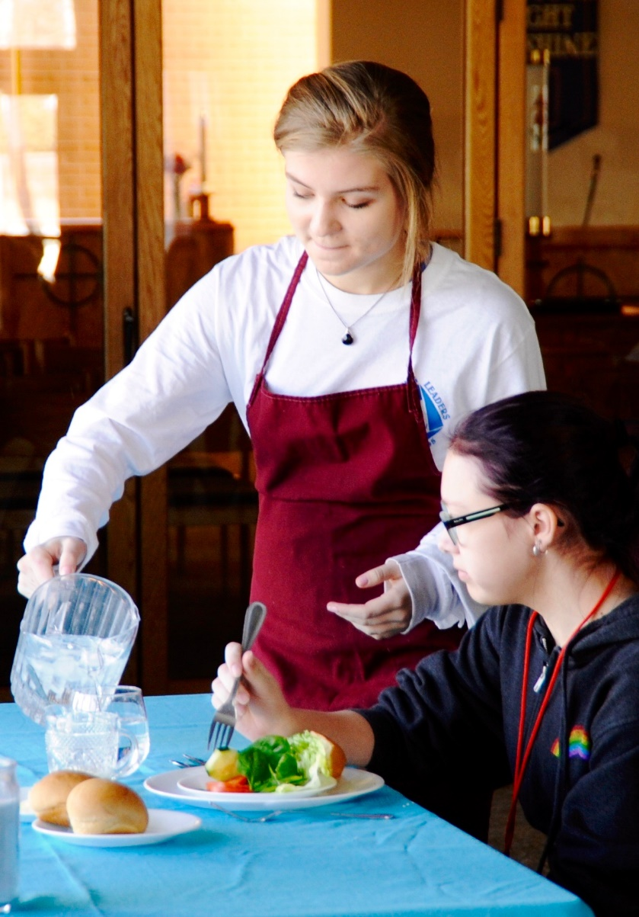

Rocky Mountain Synod Middle School Youth Gathering
Sophia Behrens
This is a guide to organizing and directing a Hunger Meal including middle school aged appropriate discussion questions and devotions. A Hunger Meal is an insightful way of showing and opening minds to what poverty looks like in our world. It also shows how we primarily focus on power and privilege in our society. This will give people a personal experience that they can relate to hunger and be and feel more educated. When others are educated on a topic they are more likely to take action to solve the issue. The Hunger Meal can be done with a variety of ages and is powerful at any point in life. These are guidelines to lead to a successful Hunger Meal that will help others grow in faith, knowledge, and love.

Table of Contents:

Leader Instructions…………………………………………………………………….……..…2
Set Up and Materials…………………………………………………..……………………….4
Discussion Questions…………………………………………………..………………..……..5
Call to Action………………………………………………………………………………………..6
Helper Scripts……………………………………………………………………………………….7
References……………………………………………………………………………………..….10

LEADER INSTRUCTIONS
Before the Meal…
• Start planning the meal about one to two months ahead of time and assemble a team if needed
o Begin with a team of 3-6 people
o Plan to have 6-10 volunteers for the event
o Have a date and time for the meal
o Find and book a location that can accommodate the amount of people you plant to have participate
This meal works best with 40-60 people
o Begin to gather supplies and materials
Tip: A good way to gat funds for the supplies is through a Thrivent Action Grant ($250)
At the beginning of the Meal…
• Have all materials ready to go and the room set up
• Have volunteers ready to read stories/perform skits
• Begin in leading a large group discussion with the “Before the Meal Discussion Questions”
• Give instructions on how the meal is going to work and split people into the different classes
o Make sure that people are put into the different classes randomly
o Make it clear that no one except the upper class person and helpers are allowed to speak during the meal
During the Meal…
• Have helpers read the scripts out loud (scripts found on page 6)
• Only pay attention to the upper class table unless the lower classes are talking (then shush them)

After the Meal…
• Break kids into small groups with a variety of classes that were played throughout the meal present
• Have you or helpers lead small group discussions (questions found on page 4)
• OPTIONAL : Prepare about 5-6 cardboard boxes with a variety of statistics on them and have them discussed during the small group time

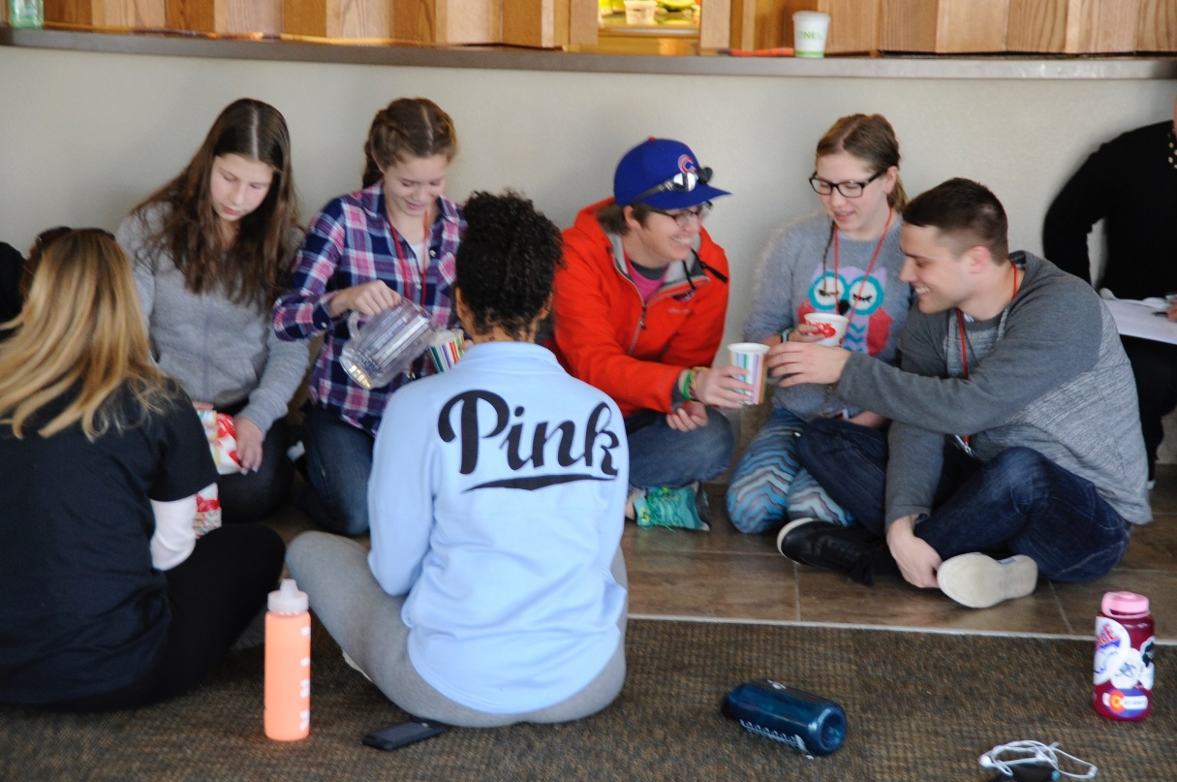

SET UP AND MATERIALS
Set Up – for 50 Hunger Meal participants
In the room where the meal is being held you will need three tables and a large space on the floor. The first table should be facing away from everyone else and only needs one chair. This table can be nicer, with candles and a tablecloth for example. The first table will be used for the upper class person. The second table will have eight chairs and will be for the upper middle class. It should be on either the right or left side of the middle of the room. There should be enough places set for the eight people. The third table should have twelve chairs but no places set. There can be a few paper plates in the middle. This is for the lower middle class. Before the meal it should have food already set out and only just enough for each person to have one serving. This table should be opposite of the upper middle class table. The final 29 participants are in the lowest class and should be seated on the floor towards the back of the room. There can be small bowls or cups in the center but there doesn’t need to be enough for everyone.
Materials
• 3 tables with chairs according to set up
• Food
o Examples:
- Rice and water for the lowest class
- Water or lemonade, a small loaf of bread, sandwich meat, American cheese, and lettuce for lower middle class
- Soda, pizza, fruit, vegetables, and cookies for upper middle class
- A choice of drinks, an appetizer, salad, chicken/steak/soup, and a dessert for upper class
• One set of dishes (for upper class)
• Paper plates, napkins. & plastic utensils (for middle classes)
• Small paper bowls (for lowest class)
• A way to randomly decide which class people are in
• Stories & scripts for helpers
• OPTIONAL FOR DISCUSSION: boxes with statistics/facts about hunger written on them (for after the meal)
• OPTIONAL FOR DRAMATIC EFFECT: classical music
Discussion Questions
Before the meal…
What is hunger?
Where do you see hunger?
Why does this place come to mind?
How many people do you think are hungry in your local community? Colorado? The U.S.? Globally?
Do you think that hunger is something that can be solved? How?
How do you see poverty portrayed in media?
How do you see wealth being portrayed in media?
Why do you think it is seen that way?
After the meal…
What did you see happen during the meal?
Which table were you at? Was there enough food for everyone?
How did watching everyone else make you feel?
How did not being able to talk make you feel?
What does it represent? Do you think this was an accurate representation?
(If boxes are used) Look at the box in front of you. Are these statistics what you expected? What surprises you?
Do you think hunger is something that can be solved?
Reread the bible verses you heard during the meal. (Luke 6:20-25, Proverbs 28:27, Acts 20:35, James 2:15-16)
What do these have to do with the meal?
Why are these verses important to remember? What are they saying?
What does reformation mean?
How are we reformed as a church?
What does being aware of and solving hunger have to do with reformation?
Call to Action (after the meal):
Through this activity I hope you are all inspired to come together as a body of Christ and resolve the issue of world hunger. Simply by being educated on this topic, you are already on your way to helping many others in your community and the world. Starting small with something such as volunteering at a food bank or helping someone on the street is the first big step in ending world hunger. If everyone is educated and an advocate, the world will be much more passionate and willing to help.
Remember that world hunger can end and is ending right now, with you.

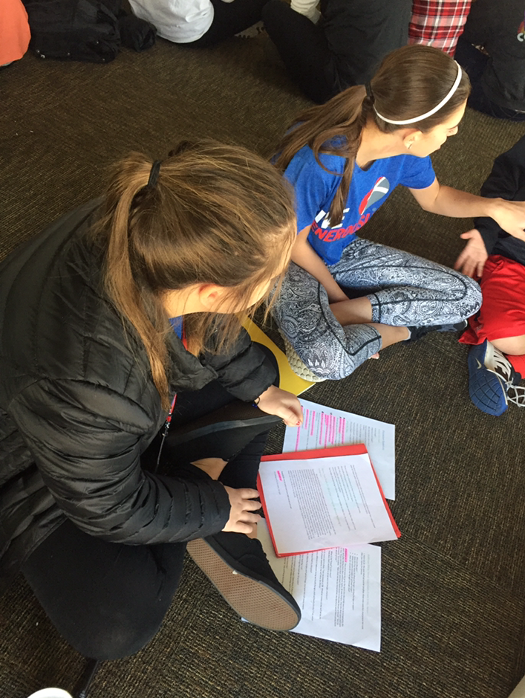

Helper Scripts
These are meant to be read out loud over the course of the meal by the volunteers.

Story One from $2.00 a Day: Living on Almost Nothing in America.
My name is Susan. I live in a small house in the south side of Chicago. It has sunken wooden steps that lead up to the closed porch which leans to the left. In order to enter the house you have to avoid the wooden board that covers the large hole in the middle of the porch. The small front door leads right into the main room. There's the old couch, the wooden coffee table, and the well-used easy chair. On the ceiling there's an odd dark patch, on the good days it is damp yet on the bad days I could swear it's crumbling. Our house doesn't have air conditioning and the windows don't open, making it even hotter than the 90 degrees it already is outside. In the back of the house, we have our kitchen. It has a large but aged refrigerator and very old porcelain sink. There's no food in the fridge except for a few bottles of baby formula that I got from WIC a local nutrition program that will sometimes supply us with that sort of thing.
There are six of us living in this house including my eight month old daughter and a few years ago this house would have been an accomplishment. But then jobs left and people left and drugs and violence arrived. My own brother was shot in broad daylight one block from this house. The neighborhood I live in and the ones surrounding us turned into a place where safety isn’t present but we can't leave since it is the only thing keeping us off the streets. With everyone living here being unemployed we have been living with less than $2 per person per day for months now. My husband has gone 6 months without finding another job and I haven't been able to find work since having my daughter. My husband still seems optimistic though and I will keep searching and working until we are no longer living off of a few food stamps that don’t bring in nearly enough and no longer living in dread and fear of what tomorrow brings.

Hunger Facts:
These facts are meant to be read aloud every couple of minutes while it is otherwise silent.
There is enough food produced to feed the earth one and a half times.
About 40% of food goes uneaten in the United States.
Over 60% of the worlds hungry is women and girls.
There are 692, 840 people who are food insecure in Colorado meaning that they don’t know where there next meal is coming from.
The number of people living in chronic hunger worldwide has fallen by 17% since the 1990’s.
Anonymous Story:
A good example of how a small change can make a big difference is a story of a student in Fort Collins that wasn’t getting food at home due to a parent’s job loss. Coming to school was purely out of necessity, for the basic need of nutrition. Since the student wasn’t coming there to learn, he was repeatedly getting into trouble and sent to the assistant principal's office. Finally, the assistant principal asked if the kid was hungry. The answer was a firm yes. After eating one of the breakfasts that are provided at the school, the student went back to class and was able to learn for the rest of the day. That student is now regularly provided with food at the Food Bank and has become a much better learner.

Story Two from $2.00 a Day: Living on Almost Nothing in America.
My name is Jennifer and I am a single mom with a ten year old and a seven year old. We have been moving from homeless shelter to homeless shelter for quite some time now. Currently, I am out of work but hopefully it won’t stay that way for long. Unfortunately, I had to quit my last job that took me ten months of endless amounts of applications to find. I use to work as a maid. We (me and the other women I worked with) would get assignments each day form cleaning condos to abandoned houses. Each day was different and we never knew how many houses we would clean that day or where or how long it would take, meaning that since we got paid by the hour, it was a different paycheck each week. After a few months of working in environments such as stuffy basements and houses with mold, I began getting sick a lot. I would be unable to show up to work and my boss began to wondering where I was. She told me that I wasn’t allowed to miss any more day and so I had to quit. Now, I’m back to the cycle of job applications and making sure my kids are healthy enough to finish school this year. I wonder how long it will take me to find my next job.

Towards the end of meal read these Bible verses out loud.
Luke 6:20-25
²⁰ Looking at his disciples, he said:
“Blessed are you who are poor,
for yours is the kingdom of God.
²¹ Blessed are you who hunger now,
for you will be satisfied.
Blessed are you who weep now,
for you will laugh.
²² Blessed are you when people hate you,
when they exclude you and insult you
and reject your name as evil,
because of the Son of Man.
²³ “Rejoice in that day and leap for joy, because great is your reward in heaven. For that is how their ancestors treated the prophets.
²⁴ “But woe to you who are rich,
for you have already received your comfort.
²⁵ Woe to you who are well fed now,
for you will go hungry.
Woe to you who laugh now,
for you will mourn and weep.

Proverbs 28:27
27 Those who give to the poor will lack nothing,
but those who close their eyes to them receive many curses.
Acts 20:35
35 In everything I did, I showed you that by this kind of hard work we must help the weak, remembering the words the Lord Jesus himself said: ‘It is more blessed to give than to receive.’ ”
James 2:15-16
15 Suppose a brother or a sister is without clothes and daily food. 16 If one of you says to them, “Go in peace; keep warm and well fed,” but does nothing about their physical needs, what good is it?

References
"Action Against Hunger." Hunger Facts | Action Against Hunger. Action Against Hunger,
2016. Web. 11 Dec. 2016.

ELCA, @ELCA. "ELCA World Hunger." ELCA.org. N.p., 2016. Web. 12 Dec. 2016.

Edin, Kathryn, and H. Luke. Shaefer. Introduction. $2.00 a Day: Living on Almost Nothing in
America. Boston: Houghton Mifflin Harcourt, 2015. Xi-Xiv. Print.

"Income and Poverty in the United States: 2015." Census.gov. United States Census
Bureau, Sept. 2016. Web. 7 Nov. 2016.

NIV. S.I. : WILKINSON HOUSE LTD, 2015. Print.

A BIG thanks to
Mikka McCracken
ELCA World Hunger
Iain Chester
ELCA World Hunger
Leta Behrens
Our Saviour’s Lutheran Church, Ft. Collins, CO
Rob Behrens
Our Saviour’s Lutheran Church, Ft. Collins, CO
Kevin Dragseth
FoCoLu
Emily Winn
FoCoLu
Steve Beumer
Florida Bahamas Synod
Brad Abbott
Sky Ranch Lutheran Camp

