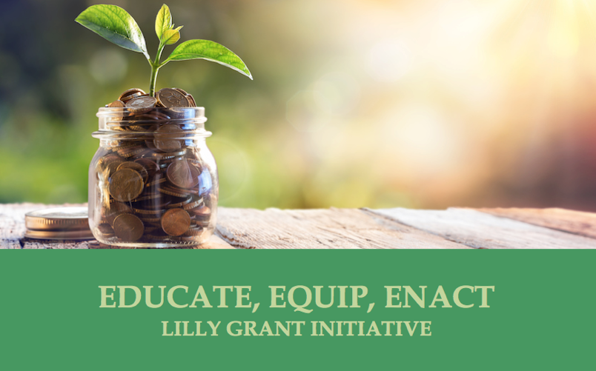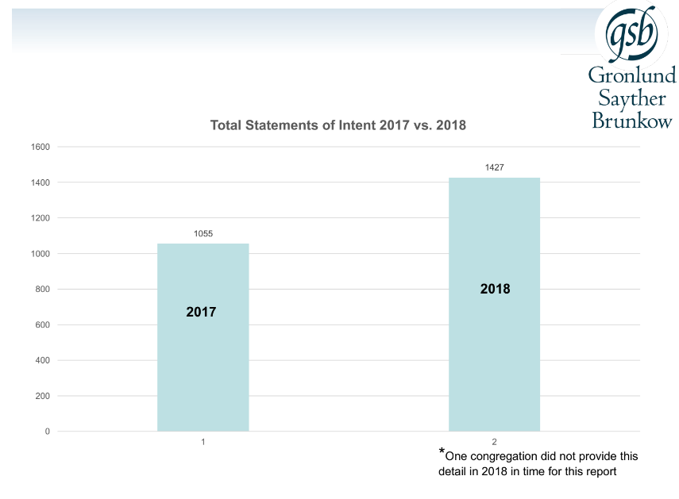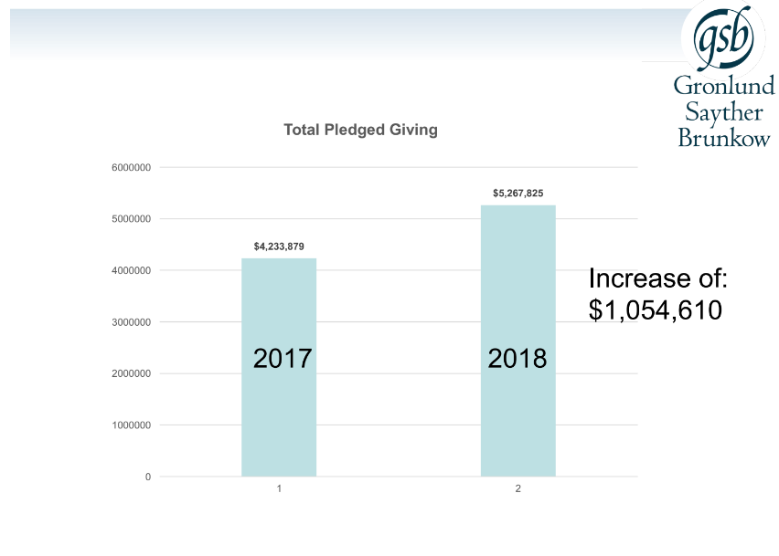

**14 Participated  
  
Congregations vary in size, average Sunday worship ranges from 81 to 370**

* STEWARDSHIP FOR ALL SEASONS
* IN COLLABORATION WITH
* THE LILLY GRANT INITIATIVE:
* EDUCATE, EQUIP, ENACT

Cohort 1 2017  
Reported results and experiences

### Cohort 1 Reported January 2017

**“The biggest change**was the council setting priorities and sharing these with the congregation ahead of time. The congregation knew that the vision is for the coming year and could get excited about it. We also realized that while we have had very strong stewardship practice of pledging, etc., we have not done a very good job at gratitude. So we are working to thanking people throughout the year.”

**“We achieved our goal**   
of a 15% budget increase for these new ministries and are keeping the congregation informed as to how the implementation is progressing.

We were fortunate enough to have a long-range plan (LRP). We tied our ministry initiatives to the missions that supported and/or enhanced our long-range plan’s objectives. The three ministries we selected all supported many of the mission our LRP. The congregation was communicated with often and in various large and small focus groups to present the information and answer questions. We publicized every answer on our website under FAQs. That page was the most visited page during the two months of the appeal process.”

## “Zion has a strong history of stewardship. I was not sure what we could gain from Stewardship for All Seasons. What I discovered was that they took us to the next level.” – Pr. Sonja Pancoast

Creating impact and changing our perspectives through  
 Stewardship for All Seasons

**One of our donors told me ,**“This is the first time you helped me understand how my offering has an impact in the congregation and outside it. We pledged more than we originally intended to because of the materials you gave us and the message I heard.”

We really worked together to create a narrative that would connect giving with mission; this congregation doesn’t have a strong culture of pledging, so one of the things the program did was encourage that change in the culture.

**“The SAS guidebook and best practices gave us**  
a template to work from which we tailored to our congregations. There were things that worked very well and some things we’ll change for the next campaign. Over the SAS campaign allowed us to talk openly about giving, challenge long-held beliefs about giving and pledging, and introduce new ideas about what God calls us to do. There was some resistance to new ideas but we also received much positive feedback. The congregation was very supportive and because of the SAS campaign we netted ~$35K for our designated ministries/projects.”

**Next Level**  
“They helped us see the places that we were already strong and then worked with us on the areas to make even better. We discovered new ways to tell the story of how people’s giving makes a difference in congregation and broader community. We also discovered ways to say thank you to people throughout the year.”

“**2017 was the first time**  
for our congregation to have an organized stewardship campaign for many years. We are working toward making stewardship a year-round endeavor and part of our church culture. Since 2017 is our new baseline, we will work upon that year’s success and build giving into our church DNA. We had a great logo and tagline, ‘Fearless Generosity’, which we’ll use again this year to promote brand recognition and, hopefully, lots of good will.”

**“Our demographics have shifted**  
in the past decade. We once were a congregation with a higher percentage of young people, and we now are more heavily represented in the young adult and adult age groups. Our hope has been, for some time, to add staff to help us minister with this growing cohort, and the strength of the congregation’s response last fall will allow us to do just that. We have also been able to continue growing in our commitment to reach beyond ourselves and make a difference in our neighborhood.”

“**Our stewardship has been flat**  
for several years, now. SAS gave us a good tool to motivate the congregation. It wasn’t a pressure campaign. Rather we were able to finds of ministry that needed more support and the congregation got behind them financially.”

# IMPACT