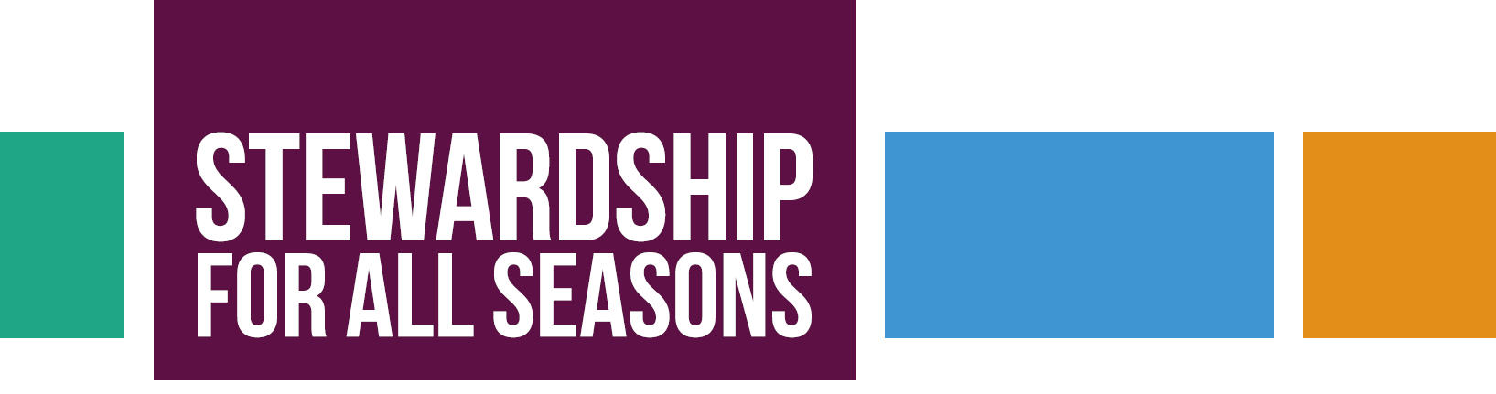
The purpose of Stewardship For All Seasons (SAS) is to guide pastors and congregation leaders to
learn tried and true basic principles and effective methodologies to carry out productive stewardship
programs. Learn how to do year-round, on-going stewardship resulting in more money for ministry, more
energized stewards, and a culture of generosity. RELY ON MORE THAN THE ANNUAL STEWARDSHIP
APPEAL. THINK STEWARDSHIP DEVELOPMENT.

BENEFITS OF STEWARDSHIP FOR ALL SEASONS

- Prepare your congregation’s story
- Educate people to tell that story
- Focus attention on your congregation’s mission
- Inspire people to give generously
- Learn tools and methods that really work
- Build a team that enjoys leading stewardship efforts
- Become confident and skilled in stewardship development
- Apply biblical principles to gain more resources for mission
- Experience the joy of asking and giving
- Avoid searching for the latest hot stewardship program
- Increase annual giving by 10 – 15% or more each year

GENERAL TIMETABLE

January-March 2018 – Congregations approve participation, sign the covenant, and select teams
May 2 – First meeting of all Rostered Ministers and at least one member of SAS team from each congregation
meet with consultant prior to Synod Assembly in Westminster
June – Electronic meeting with consultant, congregational council and SAS team to discuss process and goal setting
Early August – First gathering of teams with consultant
August 30 – September 15 – Individual consultations by Skype/GoTo mtg
Late September – Electronic meeting
September 17-20 – Check in with Rostered Ministers at Theological Conference
Oct 1– Nov 30 – Congregational appeals conducted
January 2019 – Meeting to launch season of Evaluation and to review results from Fall drive
March 2019 – Meeting to look at special giving options
WHAT OTHERS ARE SAYING

16 congregations in the Rocky Mountain Synod are engaged in Stewardship for All Seasons in 2017-2018.

James Gardner, SAS Team Leader in Zion, Salt Lake City
Stewardship for All Seasons is a positive plan for putting together our goals and then expressing them in financially positive Action. The short-term components are clear and grab-able. The long-term trajectory is compelling — because we have an opportunity to advance the Gospel of Christ, the Kingdom of God.
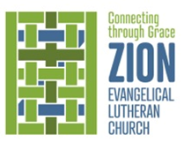
For we are Connected (and Compelled) by Grace (into Grace).

Pr. Steve Klemz, Zion, Salt Lake City
Our participation in SAS has already made an impact upon our mission and ministry. We have adopted a new mission statement: Connecting through Grace. As is required by SAS, we were moved to create a new logo, which feels like a breath of fresh air, providing a new energy for ministry.

Through SAS we are learning to better clarify and articulate new directions and opportunities for mission. I am already looking forward to our annual meeting in November. Rather than negotiating a budget, we will be celebrating new venues in mission and ministry.

SAS is a call to repentance. As pastor and congregation, we have been negligent in stewardship ministry, settling for a meet-the-budget approach. More than a financial appeal, we are looking to grow into a culture of generosity. We pray the Spirit’s blessing, that we may move into “conversion,” as Nouwen describes it in “A Spirituality of Fundraising” -
Indeed, living a spiritual life requires a change of heart, a conversion. Such a conversion may be marked by a sudden inner change, or it can take place through a long, quiet process of transformation. --- p. 17

COST FOR STEWARDSHIP FOR ALL SEASONS

Because of the Rocky Mountain Synod’s relationship to Gronlund Sayther Brunkow, and the generous support from Educate, Equip, Enact, Stewardship for All Seasons is available to our congregations for $2900 plus the cost of a professional graphic artist ($675 if contracted through SAS).

For 2018-2019:
8 scholarships of $1500 are available for congregations with an operating budget under $300,000
8 scholarships of $2000 are available for congregations with an operating budget under $200,000
7 scholarships of $2500 are available for congregations with an operating budget under $100,000

TO LEARN MORE

Contact Debra Elstad, Educate, Equip, Enact Steering Team, email: deb.elstad@gmail.com or 801-712-5108

